**A PROJECT REPORT ON**

**IOT Sensor-based smart home management for human needs through Micro controller**

***Mini project submitted in partial fulfillment of the requirements for the***

***award of the degree of***

**BACHELOR OF TECHNOLOGY**

**IN**

**INFORMATION TECHNOLOGY**

**(2020-2024)**

**BY**

**SAI SIVA KUMAR SARMA.I 20241A1240**

**P.SATISH 20241A1238**

**NAVEEN DEVANANDI 20241A1237**

***Under the Esteemed guidance***

***of***

**P.GOPALA KRISHNA**

**Associate Prof**

**Dept of IT.**



**DEPARTMENT OF INFORMATION TECHNOLOGY**

**GOKARAJU RANGARAJU INSTITUTE OF ENGINEERING AND TECHNOLOGY**

**(AUTONOMOUS)** **HYDERABAD**



***CERTIFICATE***

This is to certify that it is a bonafide record of Mini Project work entitled **“IOT Sensor-based smart home management for human needs through Micro controller”** done by **Sai Siva Kumar Sarma.I (20241A1240), P.Satish(20241A1238),Naveen Devanandi(20241A1237)** of **B.Tech (IT)** in the Department of Information Technology, **Gokaraju Rangaraju Institute of Engineering and Technology** during the period 2019-2023 in the partial fulfillment of the requirements for the award of degree of **BACHELOR OF TECHNOLOGY IN INFORMATION TECHNOLOGY** from GRIET, Hyderabad.

**P.GOPALA KRISHNA, Dr.N.V.Ganapathi Raju ,**

**Associate Professor Head of the Department,**

**(Internal project guide)**

**(Project External)**

**ACKNOWLEDGEMENT**

We take immense pleasure in expressing gratitude to our Internal guide**, P.GOPALAKRISHNA**

**Associate Prof, Dept. of IT**, GRIET. We express our sincere thanks for her encouragement,

suggestions and support, which provided the impetus and paved the way for the successful completion of the project work.

We wish to express our gratitude to **Dr. N. V. Ganapathi Raju,** HOD IT **,** our Project Co-ordinators**, K. Archana** for their constant support during the project.

We express our sincere thanks to **Dr. Jandhyala N Murthy,** Director, GRIET**,** and **Dr. J. Praveen,** Principal, GRIET**,** for providing us the conductive environment for carrying through our academic schedules and project with ease.

We also take this opportunity to convey our sincere thanks to the teaching and non-teaching staff of GRIET College, Hyderabad.

|  |  |
| --- | --- |
|  |  |
| Name: Sai Siva Kumar Sarma.I  Email: issksharma2020@gmail.com  Contact No: 9160260045  Address: Kukatpally, Hyderabad. | Name: P. Satish  Email:puttapallisatish9010@gmail.com  Contact No: 6305197180  Address: Bachupally, Hyderabad |
|  | |
| Name: Naveen Devanandi  Email: devanandinaveen@gmail.com  Contact No: 9066309666  Address: vidyanagar, jagtial | |

**DECLARATION**

This is to certify that the project entitled “**IOT Sensor-based smart home management for human needs through Micro controller”** is a bonafide work done by us in partial fulfillment of the requirements for the award of the degree **BACHELOR OF TECHNOLOGY IN INFORMATION TECHNOLOGY** from Gokaraju Rangaraju Institute of Engineering and Technology, Hyderabad.

We also declare that this project is a result of our own effort and has not been copied or imitated from any source. Citations from any websites, books and paper publications are mentioned in the Bibliography.

This work was not submitted earlier at any other University or Institute for the award of any degree.

**SAI SIVA KUMAR SARMA.I 20241A1240**

1. **SATISH 20241A1238**

**NAVEEN DEVANANDI 20241A1237**

**TABLE OF CONTENTS**

|  |  |  |
| --- | --- | --- |
| **Serial no** | **Name** | **Page no** |
|  | **Certificates** | ii |
|  | **Contents** | v |
|  | **Abstract** | vii |
| **1** | **INTRODUCTION** | 1 |
| 1.1 | Introduction to project | 1 |
| 1.2 | Existing System | 2 |
| 1.3 | Proposed System | 3 |
| **2** | **REQUIREMENT ENGINEERING** | 4 |
| 2.1 | Software Requirements | 4 |
| 2.2 | Hardware Requirements | 9 |
| **3** | **LITERATURE SURVEY** | 17 |
| **4** | **TECHNOLOGY** | 19 |
| **5** | **DESIGN REQUIREMENT ENGINEERING** | 25 |
| 5.1  5.2 | UML Diagrams  Sequence Diagram | 25  26 |
| 5.2 | Activity Diagram | 27 |
| 5.3 | State-chart Diagram | 29 |
| 5.4 | Data Flow Diagram | 30 |
| 5.5 | Architecture | 31 |
| **6** | **IMPLEMENTATION** | 33 |
| 6.1  6.2 | Sample Code  Circuit before execution | 33  41 |
| **7**  **8** | **RESULTS**  **SOFTWARE TESTING** | 42  44 |
| **9**  **10** | **CONCLUSION AND FUTURE ENHANCEMENT**  **BIBLIOGRAPHY** | 45  46 |

**LIST OF FIGURES**

|  |  |  |
| --- | --- | --- |
| **S No** | **Figure Name** | **Page no** |
| **1**  **2** | Smart home management  Face Detection | **2**  **3** |
| **3**  **4** | GSM BASED  Arduino IDE Default Page | **3**  **8** |
| **5** | Icons In Arduino IDE | **9** |
| **6**  **7** | Microcontroller  LCD | **10**  **11** |
| **8** | LCD Pins | **12** |
| **9** | Interfacing of LCD with Controller | **13** |
| **10** | Power Supply | **15** |
| **11**  **12**  **13**  **14**  **15**  **16**  **17**  **18**  **19**  **20**  **21**  **22**  **23**  **24**  **25**  **26**  **27**  **28** | Biometric Sensor  Rain Sensor  Intro to IOT  IOT Devices  IOT Communication Protocol  Network Infrastructure  Cloud  Data Analytics  Mobile App  Sequence Diagram  Activity Diagram  State Machine Diagram  DFD  Architecture  Circuit  Circuit after power supply  LCD Display  Song display | **16**  **16**  **20**  **20**  **21**  **22**  **22**  **23**  **24**  **26**  **28**  **29**  **30**  **31**  **40**  **41**  **42**  **43** |
|  |  |  |

**ABSTRACT**

Smart home technology is emerging rapidly as an exciting new paradigm. Appliances inside the home can be watched over, managed, and controlled by the consumer. Additionally, the gadgets are linked together via the internet, enabling the user to remotely control features like home lighting, air conditioner, and security systems. In order to aid the elderly and others with disabilities, this paper's major goal is to teach consumers how to properly handle their household appliances. Thus, a smart home is being developed where the environmental conditions like air conditioner, television and lights adjust themselves with the person entering into the room or even according to the weather conditions. Due to the complexity , in this project an Microcontroller, LCD and other necessary materials in place of TV,AC and light are used to show that if a house consists of two or more people how the LCD will adjust itself and displays the standard required channel, likewise same LCD adjusts itself to the standard temperature required by the person and similarly adjusts itself according to the person entering into the room. Additional to this, if it is raining outside the LCD will be displaying a monsoon mood song, this is done using rain sensor. If these sensors are connected to the cloud then the information related to the person entering the room is stored. This information can be accessed using your mobile.

**Keywords(s):** smart home, home automation, LCD, Internet of things, security systems

1. **INTRODUCTION**
   1. **Introduction to the project:**

The Internet of Things (IoT) is a system of interrelated computing devices, mechanical and digital machines, objects, animals or people that are provided with unique identifiers and the ability to transfer data over a network without requiring human-to-human or human-to-computer interaction [1]. In the context of smart homes, IoT refers to the use of connected devices to automate and control aspects of a home, such as lighting, thermostats, security systems, and appliances. Smart home devices can be controlled using a smartphone, tablet, or voice command, and they can be programmed to perform tasks based on a variety of criteria, such as time, location, or environmental conditions. Here are some of the benefits of using IoT in smart homes: Increased convenience: Smart home devices can make it easier to control your home's environment and appliances. For example, you can use a smart thermostat to adjust the temperature in your home from anywhere, or you can use a smart lock to lock or unlock your door without having to fumble with keys.

Improved security: Smart home devices can help to improve the security of your home by providing remote monitoring and control of your security system. For example, you can use a security camera to keep an eye on your home while you're away, or you can use a smart doorbell to see who's at your door without having to get up. Reduced energy consumption: Smart home devices can help you to reduce your energy consumption by automating tasks such as turning off lights when you leave home or adjusting the thermostat when you're asleep. Enhanced comfort: Smart home devices can help you to create a more comfortable environment in your home by automating tasks such as turning on the lights when you come home or adjusting the thermostat to your desired temperature. Overall, IoT has the potential to revolutionize the way we live in our homes.

By making our homes more convenient, secure, energy-efficient, and comfortable, IoT can help us to live better lives. Smart home management refers to the use of technology and automation to control and manage various aspects of a home, such as lighting, heating, security systems, entertainment systems, and other devices. It involves the integration of smart devices, sensors, and connectivity technologies to provide homeowners with greater convenience, energy efficiency, and enhanced control over their living environment [2]. It often includes security features to enhance home safety. Smart home management systems are designed to integrate and communicate with various devices and platforms. With smart home management, homeowners can remotely control and monitor their home from anywhere with an internet connection. This means you can adjust the thermostat, turn on/off lights, or check security cameras even when you're away from home. Remote access provides convenience, security, and peace of mind. It offers customization options, allowing users to personalize their preferences and settings. One of the significant advantages of smart home management is the ability to automate various tasks and routines. Homeowners can create schedules or use sensors to trigger specific actions automatically [3]. It often have a central hub or control panel that allows homeowners to manage and control all the connected devices and systems in their home from a single interface. It can incorporate biometric sensors for enhanced safety and security purposes. Biometric sensors utilize unique physical or behavioral characteristics of individuals to verify their identity. Biometric sensors, such as fingerprint scanners can be integrated into smart home management systems to provide secure access control. Homeowners and authorized individuals can gain entry to the home by authenticating their biometric information, ensuring that only approved individuals can access the premises. Biometric sensors can be used to create individual profiles for different members of the household. Each person's unique biometric data can be stored and associated with their profile within the smart home management system [4]. This allows for personalized settings and access permissions, ensuring that each person has a tailored experience while maintaining security.

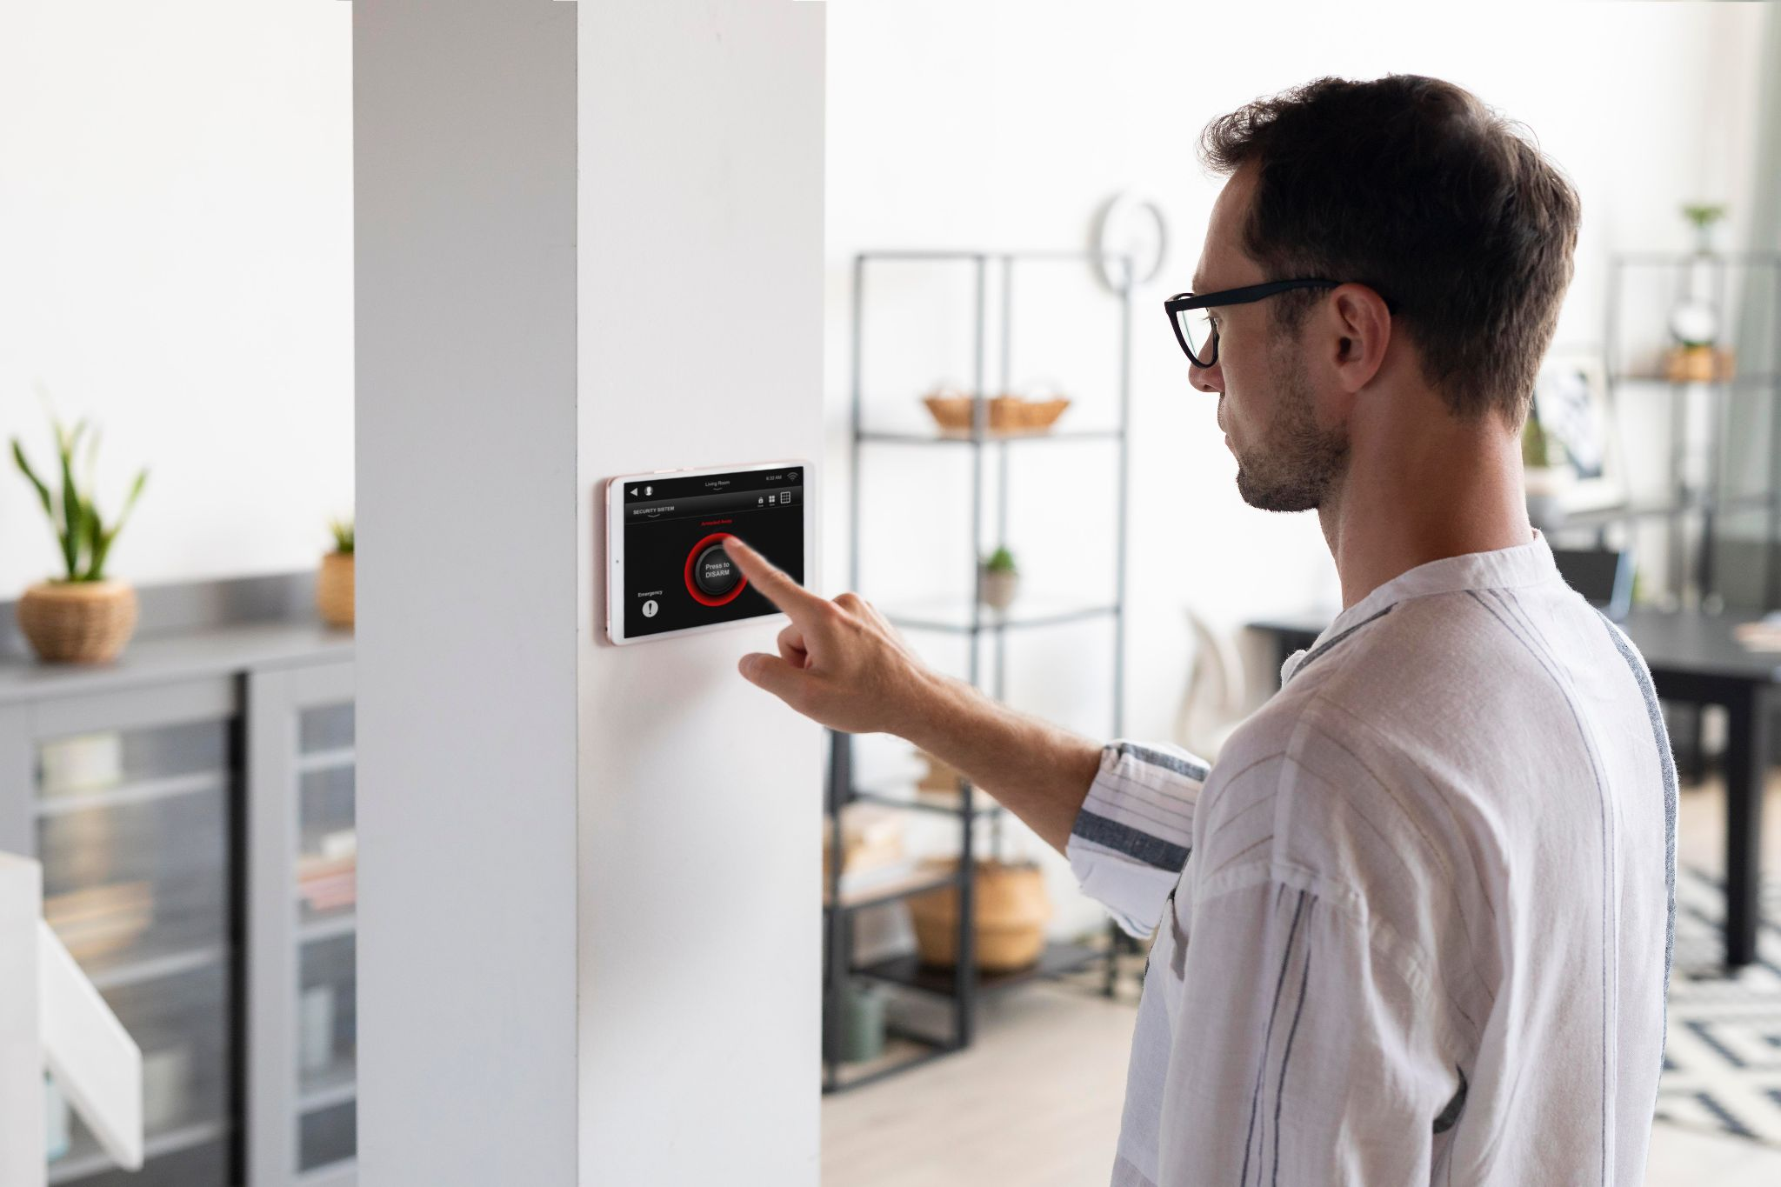

**Figure 1:** Smart home management

**1.2 Existing Systems:**

**1.TRADITIONAL PERSON DETECTION:**

With the help of sensors and Raspberry pi people can detect the persons who are near the door and can allow only those people whose face or touch id matches with the house members. This information can be seen from the owner’s mobile directly.

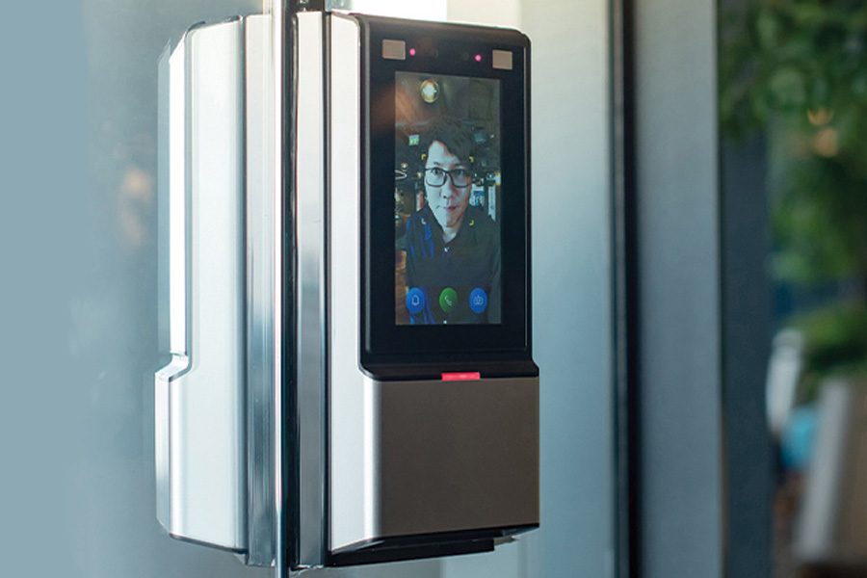

**Figure 2:** Face Detection

**2.GSM BASED SMART HOME AUTOMATION:**

Global System for Mobile Communication (GSM) modem is used to control home appliances such as light, conditional system, and security system via Short Message Service (SMS) text messages.

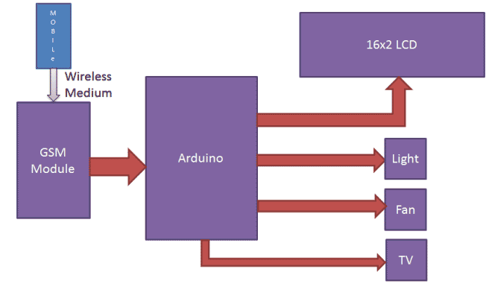

**Figure 3:** GSM BASED

**Disadvantages of Existing System:**

• The traditional system can only sense who can enter into the house but cannot manipulate the devices according to the person detection.

• Similarly, the GSM also cannot change according to the person.

**1.3 Proposed System:**

Due to the complexity, in this project an ESP32, LCD and other necessary materials in place of TV, AC and light are used to show that if a house consists of two or more people how the LCD will adjust itself and displays the standard required channel, likewise same LCD adjusts itself to the standard temperature required by the person and similarly adjusts itself according to the person entering into the room. Additional to this, if it is raining outside the LCD will be displaying a monsoon mood song, this is done using rain sensor. If these sensors are connected to the cloud then the information related to the person entering the room is stored. This information can be accessed using your mobile.

**Advantages of Proposed System**:

1. In this we can adjust the devices accordingly with the persons entering into the room.

2.We can also detect the rain and can also display the song when it rains.

3.We can send the information related to the person entering the home and the changes are done into the cloud.

**2. REQUIREMENT ENGINEERING**

**2.1 Software Requirements:**

The product viewpoint and features, operating system and operating environment, graphics requirements, design limitations, and user documentation are all part of the functional requirements or overall description papers.

The application of requirements and implementation restrictions provides an overall picture of the project in terms of what areas of strength and weakness exist and how to address them.

* Operating System: - Windows 8/10/11
* Technology: IOT
* Software: Arduino IDE software platform
* Cloud platform-Thing Speak

**2.1.1 ABOUT ARUDINO IDE:**

Arduino is a versatile and user-friendly open-source prototype platform that combines hardware and software components. It comprises a circuit board, known as a microcontroller, and an integrated development environment (IDE) called Arduino IDE. The Arduino Uno, Mega, Demilune, and Arduino Nano are some popular board variants. These boards can draw power from either a connected computer via USB or an external power supply. For Arduino users, it is important to ensure that the board is configured to draw power from the USB connection. This can be achieved by using a jumper, a small plastic piece that fits onto specific pins near the USB and power jacks. By placing the jumper on the two pins closest to the USB port, the Arduino will draw power from the USB connection. To get started, connect the Arduino board to your computer using a USB cable. Upon successful connection, the power LED (labeled PWR) on the board should illuminate, indicating that power is being supplied to the board. Arduino's combination of hardware and software components makes it an accessible platform for prototyping and developing various projects. Its ease of use, wide range of board options, and the ability to draw power from multiple sources contribute to its popularity among hobbyists, students, and professionals alike.

**2.1.1.1 The key features are:**

* Arduino is renowned for its versatility and user-friendly nature as an open-source prototype platform. It seamlessly combines both hardware and software components, featuring a microcontroller circuit board, commonly known as a microcontroller, and the Arduino IDE, an integrated development environment. Popular board variants include Arduino Uno, Mega, Duemilanove, and Arduino Nano. These boards offer the flexibility to draw power from either a connected computer via USB or an external power supply.
* When using Arduino Diecimila, it is crucial to ensure proper configuration to enable power draw from the USB connection. This involves using a jumper, a small plastic component that fits onto specific pins located near the USB and power jacks. By placing the jumper on the two pins closest to the USB port, the Arduino board can effectively draw power from the USB connection.
* To initiate the use of Arduino, the initial step is to connect the Arduino board to your computer using a USB cable. Upon establishing a successful connection, you can verify the power supply by checking the illumination of the power LED (labeled PWR) on the board. The presence of this illuminated LED indicates that the board is receiving power. Arduino's integration of hardware and software components makes it an accessible platform suitable for a diverse range of projects.
* Its user-friendly interface, extensive selection of board options, and the capability to draw power from various sources contribute to its widespread popularity among hobbyists, students, and professionals.

**2.1.1.2 Arduino data types:**

In C programming, the data types encompass a comprehensive system that allows programmers to declare variables or functions with various characteristics. The choice of a specific data type for a variable is crucial as it determines the allocation of storage space and the interpretation of the stored bit pattern. This system provides a wide range of data types, enabling programmers to represent different forms of data, such as integers, characters, floating-point numbers, and more. By carefully selecting the appropriate data type, programmers can optimize memory usage, ensure efficient data manipulation, and improve the overall reliability and performance of C programs. Having a solid understanding of data types and utilizing them effectively is essential for developing robust and efficient software solutions in the C programming language.

Below is a table outlining the data types commonly used in Arduino programming:

**Void:**

The void keyword is specifically employed in function declarations to specify that the function does not return any data to the calling function. It serves as an indication that the function does not produce a result that can be used or accessed by the calling code. Instead, it performs a task or executes a set of instructions without providing any return value.

**Boolean:**

A Boolean is a data type that can hold either true or false values. It is typically used to represent logical conditions in programming. In memory, a Boolean variable occupies one byte.

**Char:**

The char data type is utilized to store a single character in C programming. It occupies one byte of memory. Characters can be represented by enclosing them in single quotes, such as 'A', and multiple characters can be stored as strings by using double quotes, like "ABC". While characters are internally stored as numeric values, they can be manipulated using their respective ASCII values.

**Unsigned char:**

The unsigned char is an unsigned data type that also occupies one byte of memory. It stores numbers from 0 to 255 and does not allow negative values.

**Byte:**

A byte is an 8-bit unsigned number that can store values ranging from 0 to 255. It is commonly used for data storage and manipulation.

**Int:**

Integers are the primary data type for storing whole numbers. The int data type typically stores a 16-bit (2-byte) value, allowing a range from -32,768 to 32,767. However, the size of int can vary depending on the specific board or platform.

**Unsigned int:**

Unsigned int is similar to int, but it only stores positive values. It also occupies 2 bytes of memory, providing a range from 0 to 65,535.

**Word:**

The word data type is used on certain boards, such as the Uno, to store a 16-bit unsigned number. On other boards like the Due and Zero, it can store a 32-bit unsigned number.

**Long:**

Long variables are used to store extended-size integers. They typically occupy 32 bits (4 bytes) and can hold values ranging from -2,147,483,648 to 2,147,483,647.

**Unsigned long:**

Unsigned long is an extended-size integer data type that stores only non-negative values. It also occupies 4 bytes of memory and has a range from 0 to 4,294,967,295.

**Short:**

A short is a 16-bit data type used to store smaller integers. It has a range from -32,768 to 32,767, similar to the int data type.

**Float:**

Float is a data type used for storing floating-point numbers, which have decimal points. They provide greater precision than integers and can represent a wide range of values, typically up to 3.4028235E+38 with 32 bits (4 bytes) of information.

**Double:**

The double data type is employed for storing double-precision floating-point numbers in C programming. On certain boards, like the Uno, it requires four bytes of memory, which is equivalent to the float data type. However, on other boards like the Due, doubles have a higher precision of 8 bytes (64 bits), offering increased accuracy for calculations.

**2.1.1.3 Structure:**

Arduino programs consist of three main sections: Structure, Values (variables and constants), and Functions. Each section plays a crucial role in the overall program execution. In this comprehensive tutorial, we will explore the Arduino software program step by step, providing valuable insights on how to write programs that are free from syntax and compilation errors. Let's dive into the first section, Structure.

This section encompasses two primary functions: **Setup()** and **Loop().**

The Setup() function serves as an initialization step when a sketch starts, performing crucial tasks such as variable setup, pin mode configuration, and library initialization. It is executed only once after each power up or reset of the Arduino board. By carefully designing the Setup() function, you can establish the initial state and lay the foundation for your program. Moving on to the Loop() function, it continuously loops, hence its name, allowing your program to actively change and respond in real-time. This function acts as the central control centre of your Arduino board, enabling the implementation of various actions and behaviour.

Within the Loop() function, you have the flexibility to define the logic and algorithms that govern the behaviour of your program. It executes repeatedly, ensuring continuous execution of desired actions and providing responsiveness to your Arduino project. By effectively utilizing the Setup() and Loop() functions, you can create Arduino programs that perform specific tasks, respond to sensor inputs, and interact seamlessly with connected hardware.

Mastering the structure of Arduino programs is crucial to fully leverage the potential of the Arduino platform. In the upcoming steps of this tutorial, we will further explore the Values and Functions sections, delving into the wide range of variables, constants, and functions that can be utilized to enhance the capabilities and functionality of your Arduino projects.



**Figure 4:** Arduino IDE Default Page

The Arduino software provides several essential buttons and features to facilitate the programming and interaction with Arduino boards. Let's explore these functionalities:

* **Upload:** By clicking the Upload button, the code written on the screen is compiled and executed. It is then uploaded to the connected Arduino board. Before uploading, it is important to ensure that the correct board and ports are selected. A USB connection is required to establish a connection between the board and the PC. Successful uploading is indicated by the glowing of the Tx and Rx LEDs. If there are any errors during uploading, a notification will appear in the error window.
* **Open:** The Open button allows you to open a previously saved file. When clicked, the selected file will open in the current window, enabling you to continue working on it.
* **Save:** The Save button is used to save the current sketch or code. By clicking this button, you can save your progress and ensure that your work is safely stored.
* **New:** The New button is used to start a new drawing or open a new tab, providing a fresh canvas for your coding endeavours.
* **Verify:** The Verify button is used to check for any compilation errors in your sketch or written code. Clicking this button allows you to ensure that your code is free from syntax errors before attempting to upload it to the Arduino board.
* **Serial Monitor:** The Serial Monitor button is located in the toolbar's right corner. By clicking this button, you can open the serial monitor on the screen. This feature allows you to monitor and interact with the data being transmitted through the serial port. Additionally, you can find other options such as verify/compile, undo, redo, and access the sketchbook.

These buttons and features enhance the Arduino programming experience, providing convenient ways to upload code, manage files, check for errors, and monitor serial communication. Mastering their usage empowers you to effectively develop and debug Arduino projects with ease.

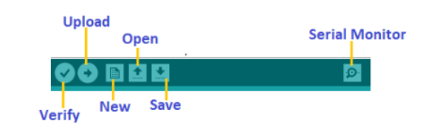**Figure 5:**  Icons In Arduino IDE

**2.2 Hardware Requirements:**

The minimum hardware requirements can differ significantly based on the specific product and the sensors involved. Devices that rely on complex applications and multiple environmental inputs typically necessitate a substantial number of sensors.

• Operating system: Windows

• Processor: Intel i3 or higher (minimum requirement)

• RAM: At least 2 GB

• Hard disk: Minimum storage capacity of 250 GB

**2.2.1** **ESP8266:**

The ESP8266 is a cost-effective, 32-bit Wi-Fi microcontroller specifically designed for Internet of Things (IoT) applications. It comes equipped with a built-in Wi-Fi radio and can be programmed using either the Arduino IDE or the ESP-IDF framework developed by Express-if. With its user-friendly nature, affordability, and extensive feature set, the ESP8266 has gained significant popularity among IoT projects. Key attributes that make it an ideal choice for IoT applications include:

1. Wi-Fi Connectivity: The ESP8266 seamlessly connects to local Wi-Fi networks, enabling communication with other devices within the network, such as computers or smartphones.
2. Microcontroller Capability: Powered by a 32-bit Tensilica Xtensa LX6 microprocessor, the ESP8266 exhibits robust processing capabilities. This allows it to efficiently run code and handle data, making it versatile for controlling various devices and systems.
3. Affordability: The ESP8266 is known for its low cost, making it a viable option for projects with budget constraints. Due to its ease of use, affordability, and wide range of features, the ESP8266 has become a preferred choice for diverse IoT applications. It finds utility in the development of smart home devices, wearables, and industrial automation systems, among other IoT-enabled creations

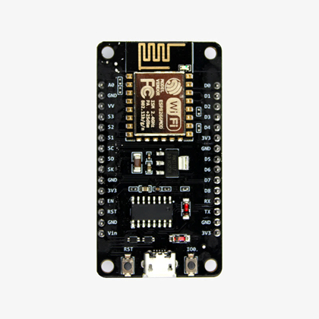

**Figure 6:**  Microcontroller

**2.2.2 Liquid Crystal Display:**

LCDs offer a versatile and cost-effective solution for displaying information in IoT devices. Their ease of use and compatibility with a wide range of applications make them a popular choice. As the IoT ecosystem continues to expand, LCDs are expected to gain further popularity in displaying sensor data, offering user feedback, and providing instructions. Liquid crystal displays (LCDs) find extensive utility in the realm of Internet of Things (IoT), serving various purposes such as: Sensor Data Display: LCDs facilitate the real-time presentation of sensor data, including metrics like temperature, humidity, and pressure. This functionality proves valuable in monitoring environmental conditions or tracking machine performance.

User Feedback: LCDs are employed to provide users with feedback on device or system status. For instance, an LCD might display a warning message if a temperature sensor surpasses a predetermined threshold. Instruction Provision: LCDs serve as a medium for delivering operational instructions to users. They can present step-by-step guides, enabling individuals to configure security systems or operate devices effectively.

Branding Opportunities: LCDs offer the ability to display branding elements, such as company or product names. This contributes to a professional and refined appearance for IoT devices. In summary, LCDs serve as a versatile and economical means of displaying information in IoT applications. Their adaptability to diverse use cases makes them an integral component in presenting sensor data, offering user feedback, delivering instructions, and establishing brand presence in IoT devices.

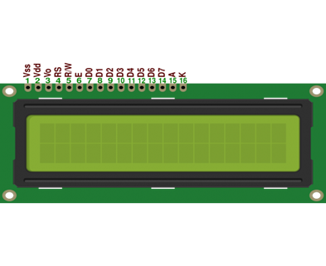

**Figure 7:**  LCD

**Pin configuration:**

Vcc, Vss, and Vee:Vcc and Vss supply +5V and ground, respectively, while Vee

controls LCD contrast.

|  |  |
| --- | --- |
| Pins | DESCRIPTION |
| 1 | Ground |
| 2 | Vcc |
| 3 | Contrast Voltage |
| 4 | “R/S” _Instruction/Register Select |
| 5 | “R/W” _Read/Write LCD Registers |
| 6 | “E” Clock |
| 7-14 | Data I/O Pins |

**Figure 8:**  LCD Pins

In an LCD interface application, the ASCII code to be displayed is typically eight bits long, but the LCD receives data in either four or eight-bit transfers. To achieve an eight-bit transfer in four-bit mode, the data is sent in two "nibbles" (high four bits followed by low four bits), with each nibble accompanied by an "E" Clock pulse.

The initiation of data flow within the LCD is triggered by the "E" Clock signal. However, the crucial decision in an LCD interface application is determining how to transmit the data to the LCD effectively. When speed is a priority and there are sufficient I/O pins available (at least ten), utilizing the eight-bit mode is the optimal choice. In this mode, the "R/S" bit determines whether the microcontroller sends data or instructions to the LCD. When the "R/S" bit is set, the microcontroller can write data to the current LCD cursor position.

Conversely, when the "R/S" bit is reset, the LCD either receives an instruction or provides the status of the last executed instruction. Therefore, selecting the appropriate data transmission mode and managing the "R/S" bit correctly are critical considerations in an LCD interface application to ensure efficient communication and control between the microcontroller and the LCD display.

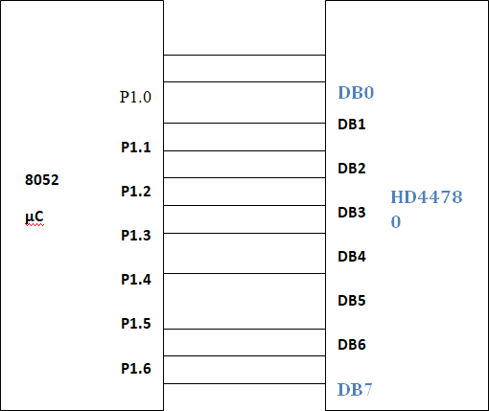

**Figure 9:** Interfacing of LCD with Controller

When working with an LCD display, there are several commands and functions available to control its behavior. The following commands are commonly used: lcd.begin(cols, rows): This command initializes the LCD display with the specified number of columns and rows. It prepares the display for use.

lcd.clear(): This command clears the contents of the LCD display, removing any previously displayed characters or symbols.

lcd.setCursor(col, row): This command sets the cursor position on the LCD display to the specified column and row. It determines where the next character or symbol will be displayed.

lcd.print(text): This command displays the specified text on the LCD display at the current cursor position. lcd.write(value): This command displays a single character represented by the specified ASCII value on the LCD display at the current cursor position.

lcd.createChar(location, charmap): This command allows you to create custom characters by defining their bitmaps. The location parameter specifies the memory location for the character, and the charmap parameter defines the character's bitmap.

To use these commands and functions, you need to include the LiquidCrystal library at the beginning of your code using the "#include <LiquidCrystal.h>" statement. This library provides the necessary functions to communicate with and control the LCD display. By using these commands effectively, you can control the content, position, and appearance of the characters and symbols on the LCD display in your project.

**Functions:**

* LiquidCrystal()
* begin()
* clear()
* home()
* setCursor()
* write()
* print()
* blink()
* autoscroll()
* leftToRight()
* rightToleft()
* createChar()

**2.2.3 Power Supply:**

The power supply refers to the source of electrical power for a device or system. It is responsible for supplying electrical or other forms of energy to an output load or a group of loads. Typically, a power supply unit (PSU) is used to fulfill this role. While the term "power supply" primarily pertains to electrical energy sources, it can also apply to mechanical or other types of energy supplies, although less frequently. In the context of power supply for electronic devices, the main objective is to convert the alternating current (AC) signal from the mains, which is typically at a voltage of 230V/50Hz, into a direct current (DC) signal. Additionally, the power supply section is responsible for reducing the signal's amplitude. Various applications require a specific DC voltage with a desired amplitude, such as +5V and +12V. Therefore, the power supply section plays a crucial role in transforming the AC signal from the mains into the required DC voltage (without frequency) while adjusting its amplitude to meet the needs of different applications.

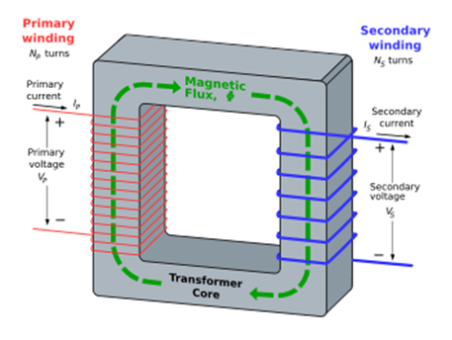

**Figure 10:** Power Supply

**2.2.4 BIOMETRIC TOUCH SENSOR:**

Biometric fingerprint sensors play a crucial role in the Internet of Things (IoT) by integrating fingerprint recognition technology into diverse devices. These sensors capture and analyze unique fingerprint patterns to enable secure and reliable authentication. In IoT applications, they provide an efficient and convenient method for user identification and access control. By employing advanced algorithms, fingerprint sensors compare the captured fingerprint data with stored templates to authenticate the user's identity. This process ensures accurate and dependable identification, making it challenging for unauthorized individuals to gain entry.

Integrating biometric fingerprint sensors into IoT devices, such as smart locks, access control systems, and biometric attendance systems, enhances security while simplifying the authentication process. One notable advantage of biometric fingerprint sensors in IoT is their compact size and low power consumption. These features enable seamless integration into a variety of IoT devices without excessive energy consumption, making them well-suited for resource-constrained environments. Moreover, biometric fingerprint sensors offer high accuracy and resistance to spoofing attempts, providing robust security measures. They eliminate the reliance on traditional authentication methods like passwords or PINs, which can be susceptible to unauthorized access or forgotten credentials.

In summary, biometric fingerprint sensors significantly contribute to improved security, streamlined user authentication, and an enhanced user experience across a wide range of IoT applications. Their integration has become indispensable in the IoT ecosystem.

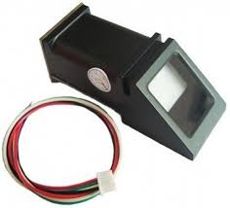

**Figure 11:** Biometric Sensor

**2.2.5 RAIN SENSOR:**

The rain sensor module is a convenient tool designed for rain detection. It serves two main purposes: functioning as a switch when raindrops fall on the raining board and measuring rainfall intensity. The module consists of a rain board and a separate control board for added convenience. It also features a power indicator LED and adjustable sensitivity through a potentiometer.

When connected to a 5V power supply, the LED will illuminate when the induction board detects no raindrops, resulting in a high output on the DO pin. However, when a small amount of water is detected, the DO output becomes low, triggering the switch indicator to turn on. If the water droplets are removed, and the sensor returns to its initial state, the output returns to a high level. The rain sensor module is built with high-quality RF-04 double-sided material, providing resistance to oxidation and conductivity for extended use. It utilizes a comparator with a clean waveform and strong driving ability, capable of handling over 15mA.

The sensitivity of the module can be adjusted using a potentiometer. Specifications of the module include a working voltage of 5V, offering both digital switching output (0 and 1) and analog voltage output (AO). The small board PCB size of 3.2cm x 1.4cm, along with bolt holes, allows for easy installation. Additionally, the module employs a LM393 comparator that supports a wide voltage range.

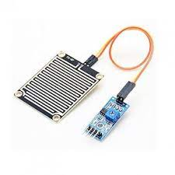

**Figure 12:** Rain Sensor

**3.LITERATURE SURVEY**

**Related Work:**

The paper proposes a system for home automation that uses Internet of Things (IoT) and touch-based controls. The system consists of a number of IoT devices, such as sensors, actuators, and a central controller. The sensors collect data about the environment, such as temperature, light, and motion. The actuators control devices in the home, such as lights, thermostats, and locks. The central controller manages the data and controls the actuators. The system is controlled using a touch-based interface. The interface allows users to control the devices in their home using simple gestures, such as tapping and swiping. The interface is also accessible to people with disabilities. The system is designed to be energy efficient. The sensors and actuators only operate when they are needed. The central controller also includes a power management module that helps to conserve energy. The system is designed to be scalable. It can be easily expanded to add new devices or sensors. The system is also designed to be secure. It uses a variety of security measures to protect the data and prevent unauthorized access. The system has been tested in a real-world setting. The results of the test showed that the system is effective and efficient. The system is also user-friendly and accessible to people with disabilities. The paper concludes by discussing the future of the system. The authors believe that the system has the potential to revolutionize the way we live in our homes. The system can make our homes more convenient, comfortable, and secure. [5]

This paper is about the IoT-based Smart Home Automation System is a cutting-edge technology that revolutionizes the way homes are managed and controlled. Developed by Ms. K. S. Gulghane, Dr. Mrs. S. S. Sherekar, and Dr. V.M. Thakare, this system leverages the power of the Internet of Things (IoT) to create a seamless and efficient home automation experience. The system enables homeowners to control and monitor various aspects of their homes remotely, using their smartphones or other smart devices. With the integration of sensors, actuators, and communication devices, the system allows users to manage lighting, temperature, security systems, and even appliances with just a few taps on their devices. One of the key advantages of this system is its ability to optimize energy consumption. By using real-time data from sensors, the system can automatically adjust lighting and temperature settings based on occupancy and ambient conditions, thereby reducing energy wastage and lowering utility bills. Furthermore, the system enhances security by providing remote monitoring and control of security devices such as cameras, door locks, and alarms. Users can receive alerts and take appropriate actions in case of any security breaches or emergencies. [6]

The Smart Home Automation System using IoT, developed by Balwinder Kaur Dhaliwal, Arvinder Kaur, Muskan Bhutani, Naman Thakur, Akash Singh, and Bhavnath Jha, is a state-of-the-art technology that transforms conventional homes into intelligent and interconnected living spaces. This system harnesses the power of the Internet of Things (IoT) to create a seamless and automated home management experience. With this system, homeowners can effortlessly control and monitor various aspects of their homes remotely using their smartphones or other smart devices. The integration of sensors, actuators, and communication devices enables users to manage lighting, appliances, security systems, and environmental conditions with ease. Energy efficiency is a key feature of this system. By utilizing real-time data from sensors, it optimizes energy consumption by automatically adjusting lighting and temperature settings based on occupancy and ambient conditions. This not only reduces energy waste but also contributes to lower utility bills. Enhanced security is another advantage of the Smart Home Automation System. Users can remotely monitor and control security devices like cameras, door locks, and alarms. Instant notifications enable homeowners to respond promptly to security breaches or emergencies. The Smart Home Automation System using IoT offers convenience, comfort, energy efficiency, and improved security to homeowners [7].

This paper is about accurately detecting the presence of humans in different environments using advanced technologies like computer vision, machine learning, and sensor integration. By employing cameras and sensors, the system captures visual data and applies computer vision techniques for image processing. Machine learning algorithms are then utilized to analyze the processed data, enabling the system to detect human features and determine their presence. The Human Detection System consists of several components, including image acquisition, image processing, and decision-making algorithms. Its architecture allows for real-time video data capture and processing, facilitating efficient human detection. The system's versatility enables its application in various scenarios such as surveillance, security systems, and human-robot interaction. Performance evaluation is based on factors like accuracy, real-time detection capabilities, and robustness. In summary, the Human Detection System developed by Ankush Muley, Piyush Changan, Balaji Londhe, and Prof. S. B. Pokharkar demonstrates a promising solution for accurately detecting human presence in diverse environments. Its integration of computer vision and machine learning technologies offers the potential to enhance security, surveillance, and interaction across a wide range of applications [8].

This paper is on developing a home automation system tailored specifically for individuals with physical limitations. The system utilizes hand gestures as the primary input method for controlling various home automation tasks, aiming to create an intuitive and accessible interface. By analyzing hand gestures, the system identifies specific commands and triggers corresponding actions, such as controlling lights, appliances, or security systems. To optimize the hand gesture recognition system, the researchers employed advanced techniques. They refined the algorithms responsible for gesture detection, classification, and mapping, ensuring accurate and efficient control of home automation tasks. The proposed system addresses the unique needs of individuals with limited physical abilities, empowering them to independently manage their home environment through intuitive hand gestures. By eliminating the requirement for physical contact with traditional switches or interfaces, the system offers a more convenient and user-friendly solution. The research team assessed the performance of the optimized hand gesture-based home automation system using various metrics, including accuracy, response time, and user satisfaction. The results demonstrated the system's effectiveness in providing reliable and efficient control over home automation tasks for individuals with physical limitations[9].

**4. TECHNOLOGY**

**4.1 ABOUT IOT:**

The Internet of Things (IoT) is a highly sophisticated system that encompasses a vast network of interconnected physical objects, each equipped with sensors, software, and network connectivity. These smart objects have the remarkable ability to collect and exchange data with other devices and systems, enabling them to gather valuable insights and facilitate seamless communication. By harnessing the power of IoT technology, various industries, including manufacturing, healthcare, and transportation, can experience transformative changes and unlock numerous benefits. In the realm of manufacturing, IoT applications offer immense potential for optimizing operational efficiency. By monitoring machine performance in real-time, manufacturers can identify bottlenecks, streamline production processes, and reduce downtime. Additionally, IoT enables predictive maintenance, allowing machines to be serviced proactively before any major issues arise. This not only saves costs but also improves overall product quality and customer satisfaction. In the healthcare sector, IoT devices play a pivotal role in revolutionizing patient care. Remote patient monitoring systems equipped with IoT sensors enable healthcare providers to monitor patients' vital signs, medication adherence, and overall well-being from a distance. This enables early detection of potential health issues and facilitates timely interventions, leading to improved patient outcomes.

Furthermore, IoT facilitates personalized healthcare solutions, where wearable devices can track individuals' health parameters and provide actionable insights for managing chronic conditions or promoting healthy lifestyles. Transportation is another domain where IoT is making significant strides. By leveraging IoT technologies, transportation systems can optimize traffic flow, reduce congestion, and enhance road safety. Smart traffic management systems equipped with IoT sensors can collect real-time data on traffic patterns, enabling authorities to make informed decisions and implement efficient traffic control measures. IoT is also revolutionizing public transportation systems, offering real-time information on bus and train schedules, occupancy levels, and optimized routes for commuters.

Moreover, smart logistics solutions powered by IoT enable efficient supply chain management, real-time tracking of goods, and seamless coordination among various stakeholders, resulting in improved efficiency and reduced costs. The evolution of IoT can be attributed to several factors, one of which is the declining cost of sensors and wireless networking technologies. As these technologies become more affordable, they enable a wider range of devices, both large and small, to connect to the internet and join the IoT ecosystem. This expansion of connectivity further enhances the potential applications of IoT, leading to even more innovative solutions and improved integration with existing systems. While IoT has gained significant traction in recent years, it is still in its early stages of development. Ongoing advancements and innovations in areas such as edge computing, artificial intelligence, and data analytics continue to push the boundaries of IoT capabilities. As technology continues to evolve, we can anticipate groundbreaking and transformative uses for IoT that will reshape industries, drive unprecedented levels of connectivity, and unlock new opportunities for growth and efficiency.

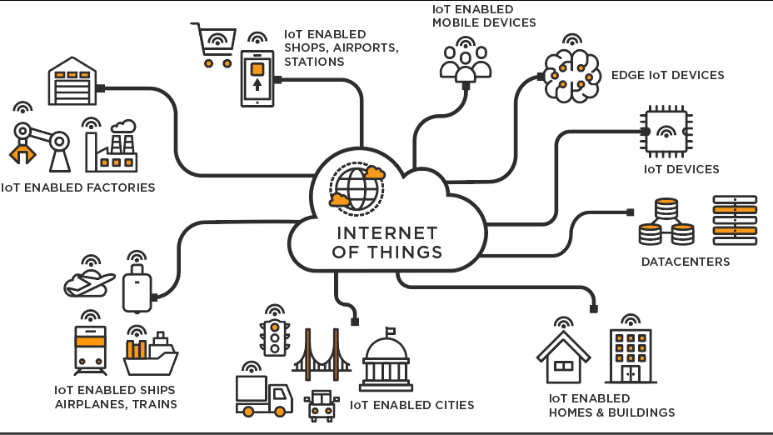

**Figure 13:**  Intro to IOT

**4.1.1 IOT Devices:**

In the project, a wide range of Internet of Things (IoT) devices are employed, encompassing sensors, actuators, and controllers that are interconnected within a network. These devices have the capability to be integrated into different objects, machinery, or surroundings, enabling the collection and transmission of data. For instance, the IoT devices utilized may consist of temperature sensors, motion detectors, smart switches, cameras, and wearable devices.

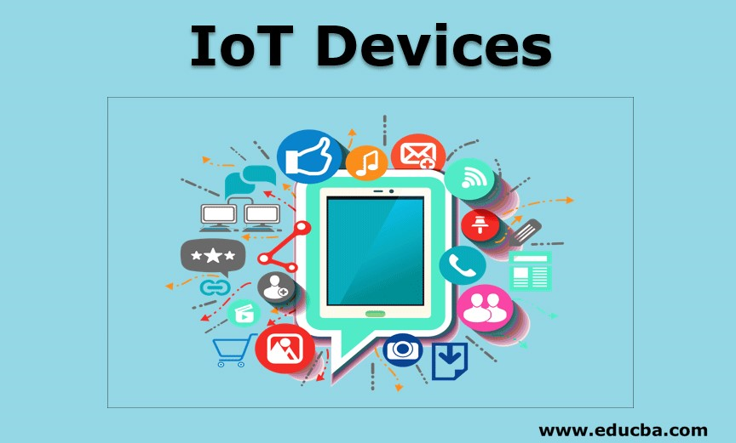

**Figure 14:** IOT Devices

**4.1.2 Communication protocols:**

In the realm of IoT, the successful communication between devices and the central system relies on the implementation of standardized protocols. These protocols act as a universal language, enabling seamless data exchange and interoperability among IoT projects. Among the widely adopted protocols in the IoT domain are MQTT (Message Queuing Telemetry Transport), HTTP (Hypertext Transfer Protocol), CoAP (Constrained Application Protocol), and WebSocket.

MQTT, a lightweight publish-subscribe messaging protocol, is ideal for resource-constrained devices and supports efficient data transmission in low-bandwidth and unreliable networks. HTTP, a well-established protocol used in web communications, facilitates data transfer between IoT devices and the central system through standard request-response interactions. CoAP, designed specifically for constrained devices and networks, ensures energy and bandwidth efficiency while providing a RESTful interface for communication.

WebSocket, a communication protocol built on top of TCP, enables full-duplex communication and real-time data streaming between IoT devices and servers. By employing these standardized protocols, IoT devices can securely and reliably transmit data to the central system. This enables structured and efficient communication, ensuring that the data collected by sensors, actuators, and controllers can be seamlessly shared, processed, and analysed. The utilization of these protocols paves the way for the advancement of IoT applications, enabling smart and interconnected systems in various domains such as home automation, industrial monitoring, healthcare, and more.

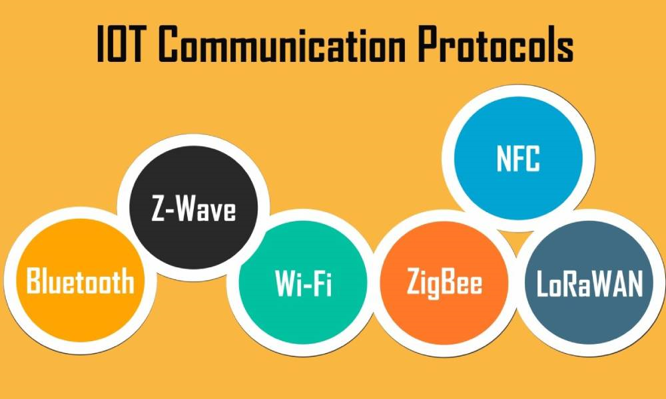

**Figure 15:**  IOT Communication Protocols

**4.1.3 Network Infrastructure:**

A reliable network infrastructure is crucial for establishing connectivity between IoT devices and the central system in the project. The selection of network technology depends on specific project requirements, ranging from wired options like Ethernet and Powerline to wireless solutions such as Wi-Fi, Bluetooth, Zigbee, and LoRaWAN. Wired technologies offer stable and high-speed communication, while wireless technologies provide flexibility and scalability. Ethernet is suitable for low-latency and high-bandwidth applications, while Powerline utilizes existing electrical wiring. Wi-Fi enables cable-free connections, Bluetooth is ideal for short-range communication, Zigbee is designed for low-power devices, and LoRaWAN allows long-range communication. Regardless of the chosen technology, a reliable network infrastructure ensures seamless data transfer, remote monitoring, and control capabilities. This facilitates real-time data collection, analysis, and management, enabling the IoT project to leverage connected devices and benefit from an interconnected ecosystem.

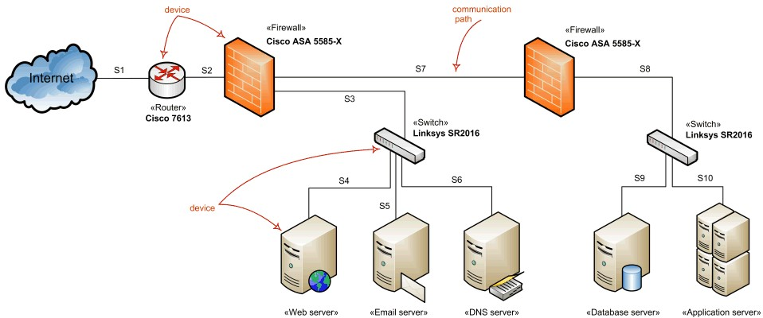

**Figure 16:**  Network Infrastructure

**4.1.4 Cloud Platform:**

The IoT project relies on a cloud platform as its core infrastructure, offering essential features like storage, processing, and analysis. This platform serves as a centralized hub for data management, ensuring scalability, accessibility, and flexibility. Leading cloud providers such as Amazon Web Services (AWS), Microsoft Azure, and Google Cloud Platform (GCP) can be utilized to handle various tasks including data storage, real-time analytics, machine learning, and seamless integration with other applications. By leveraging these cloud services, the project benefits from reliable and scalable infrastructure, enabling efficient data processing, advanced analytics, and seamless connectivity within the IoT ecosystem.

In this project, we have selected Thing speak as the platform to display and store the information collected from our system. Thing speak serves as an efficient cloud-based solution that enables us to securely store and access data. By utilizing Thing speak, we can effectively showcase the real-time information and provide users with a seamless experience. The platform's robust capabilities allow for easy integration and visualization of data, enhancing the overall functionality and usability of our smart home management system. Furthermore, leveraging Thingspeak's cloud infrastructure ensures the reliability and scalability of our project, paving the way for future advancements and improvements in the field of IoT-based home automation.

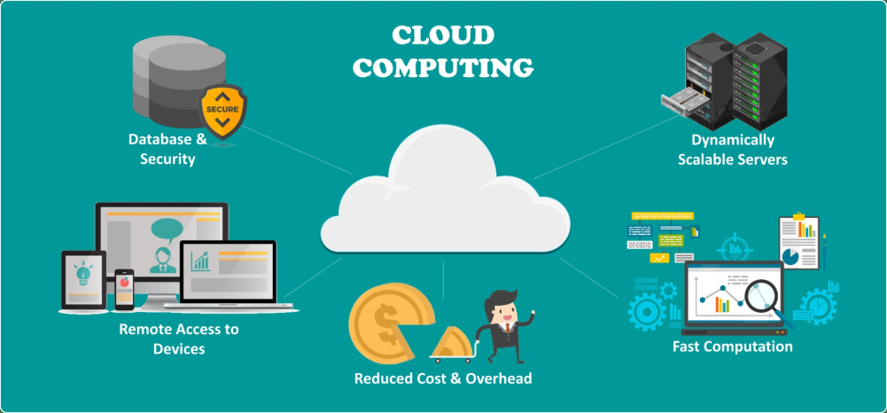

**Figure 17:**  Cloud

**4.1.5 Data Analytics:**

The data collected from IoT devices undergoes processing and analysis to extract valuable insights and facilitate informed decision-making. Through the application of data analytics techniques like descriptive analytics, predictive analytics, and prescriptive analytics, patterns can be identified, anomalies detected, and actionable recommendations generated. This enables real-time monitoring, predictive maintenance, and optimization of operational processes within the IoT project. By leveraging data analytics, the project can derive meaningful information from the collected data, leading to enhanced efficiency, improved performance, and informed decision-making.

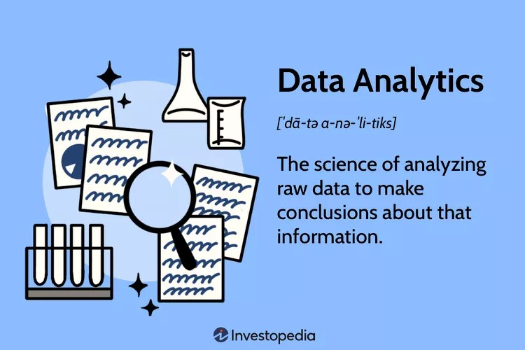

**Figure 18:**  Data Analytics

**4.1.6 Mobile (or) Web Application:**

To ensure a smooth and intuitive user experience, a user-friendly mobile or web application is designed and developed as the primary interface for users to interact with the fuel monitoring system. This application serves as a centralized hub, providing users with convenient access to real-time fuel data, alerts for potential theft or low fuel levels, and remote control and configuration options. Whether accessed through a mobile device or web browser, the application enables users to efficiently manage and oversee fuel monitoring operations. By offering a user-friendly interface, the application simplifies the process of monitoring and controlling the fuel system, empowering users to make informed decisions and take necessary actions promptly.

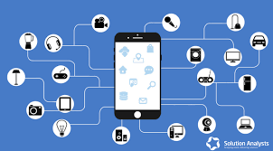

**Figure 19:**  Mobile App

**4.2 APPLICATIONS OF IOT:**

IoT has diverse applications across various industries, including:

* Smart Homes: IoT enables homeowners to connect and control devices, such as lights, thermostats, and security systems, remotely through smartphones or voice assistants.
* Industrial Automation: IoT is used to monitor and optimize industrial processes, improving efficiency, reducing downtime, and enabling predictive maintenance.
* Healthcare: IoT devices and sensors enable remote patient monitoring, real-time health tracking, and efficient healthcare management.
* Agriculture: IoT-based systems monitor soil conditions, automate irrigation, and provide data-driven insights for precision farming, leading to improved yields and resource utilization. Transportation: IoT is used for vehicle tracking, fleet management, and optimizing traffic flow, enhancing safety and efficiency.
* Retail: IoT devices provide personalized shopping experiences, inventory management, and data-driven marketing strategies to improve customer satisfaction and increase sales. These applications showcase how IoT revolutionizes industries by connecting devices, collecting data, and enabling smarter decision-making and automation.

**5. DESIGN REQUIREMENT ENGINEERING**

**Concept of UML:**

Unified Modelling Language (UML) is a widely used and standardized modelling language in the field of object-oriented software engineering. It was developed and is overseen by the Object Management Group (OMG). UML aims to become the industry standard language for modelling object-oriented computer programs. The language comprises two main components: a meta-model, which defines the language itself, and a notation, which provides graphical symbols for representing system designs. UML serves as a comprehensive language for modelling various domains, including business processes, non-software systems, and software artifacts.

It offers a set of best engineering practices that have proven effective in simulating complex systems. As an integral part of the software development process, UML enables the creation and documentation of object-oriented software. It employs graphical notations, allowing designers and developers to visually represent and communicate their software project designs.

In the future, UML may continue to evolve and potentially integrate with additional methods or processes to further enhance its capabilities. Overall, UML plays a critical role in facilitating the design, visualization, construction, and documentation of software systems, contributing to the success of object-oriented software development.

**UML DIAGRAMS:**

**5.1 Sequence Diagram:**

A sequence diagram is a powerful interaction diagram that visually represents the dynamic behavior of a system by illustrating how objects interact and exchange messages over time. It offers a time-ordered depiction of these interactions, capturing the sequence and flow of messages between objects. The essential components of a sequence diagram include actors, which represent external entities interacting with the system, and objects, which represent entities existing within the system.

These elements are visually represented by stick figures and boxes, respectively. Messages, depicted as arrows, signify the communication between objects. The vertical axis of the sequence diagram signifies the passage of time, with objects positioned from top to bottom according to their creation order. Messages are arranged horizontally from left to right, reflecting the order in which they are sent. Sequence diagrams find widespread use in various domains.

They are effective for modeling and analyzing the execution of business processes, illustrating the control flow within software applications, and capturing the interactions between different software components. These diagrams are invaluable to software developers and system analysts, assisting in comprehending system dynamics, identifying potential issues, designing new systems, and documenting existing ones. By providing a visual representation of object interactions and message exchanges, sequence diagrams enhance the understanding and analysis of complex systems, facilitating efficient communication and collaboration among project stakeholders.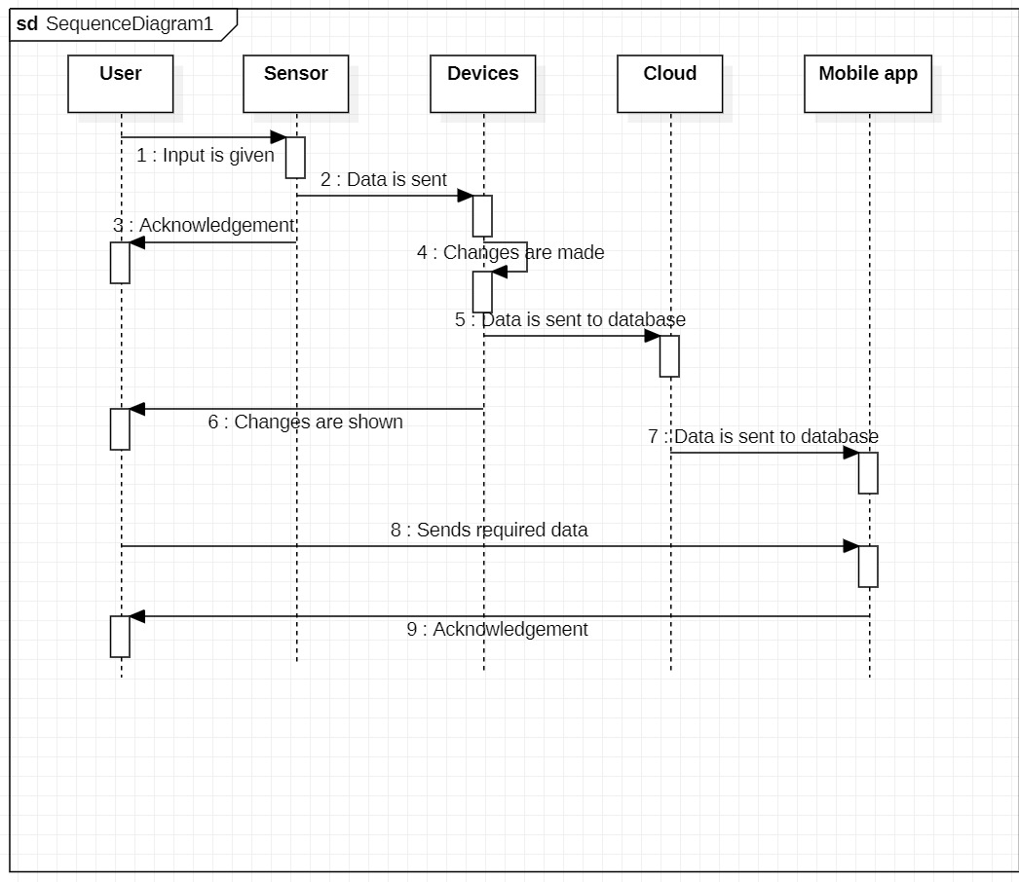

**Figure 20.** Sequence Diagram

**5.2 Activity diagram:**

An activity diagram is a behavioral diagram in the Unified Modeling Language (UML) that visually represents the flow of activities, actions, and decisions within a system. It provides a high-level view of the dynamic behavior of a system, showcasing the sequence of activities and the control flow between them.

Activity diagrams consist of nodes, edges, and actions. Nodes represent the activities or actions that take place within the system, while edges depict the control flow between these activities. Actions are the specific tasks or operations performed during the execution of an activity. Arrows or edges connect the nodes, indicating the control flow and the order in which activities are performed. Additionally, activity diagrams can include swim lanes, which are horizontal or vertical partitions that group activities based on the responsible entity or system component.

Activity diagrams are used to model the dynamic behavior of a system, including business processes, use cases, and system workflows. They provide a clear and concise visualization of how activities are organized and executed, allowing stakeholders to understand the sequence of actions, decision points, and parallel processes. Activity diagrams facilitate communication and collaboration among stakeholders, aid in system analysis and design, and serve as a blueprint for implementing and managing complex systems.

By using activity diagrams, stakeholders can identify potential bottlenecks, inefficiencies, or areas for improvement in a system's workflow. They can also help in identifying dependencies, resource allocation, and the overall logic of the system's behavior. Activity diagrams are a valuable tool in the software development lifecycle, enabling effective analysis, design, and documentation of system behavior.

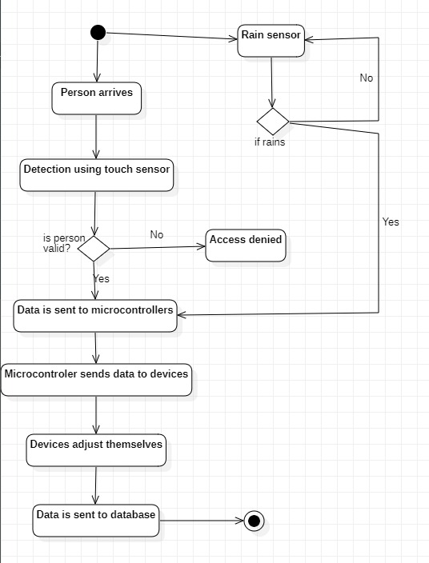

**Figure 21:** Activity Diagram

**5.3 State Machine Diagram:**

A state machine diagram is a visual representation within the Unified Modeling Language (UML) that illustrates how an object transitions between different states in response to events. It is a modeling technique used to depict the behavior of an object or system over time. In a state machine diagram, states represent the various conditions or modes that an object can be in. Transitions indicate the movement from one state to another, triggered by events. Events can be either internal, originating from within the object, or external, coming from outside sources. State machine diagrams have broad applications across different domains, including software systems, hardware systems, and business processes. They provide a clear and concise overview of the dynamic behavior of a system, aiding in understanding, analysis, and documentation. By utilizing state machine diagrams, developers and analysts can gain valuable insights into how objects or systems behave under different circumstances.

These diagrams help identify potential issues, such as missing or redundant states or unintended transitions. They also facilitate effective system design, ensuring that the desired behavior and logic are accurately captured. State machine diagrams are particularly useful in software development, where they assist in modeling complex behaviors and interactions between system components. They can also be applied in hardware design to describe the operational modes of a device or in business process analysis to visualize the flow and decision-making processes within a system.

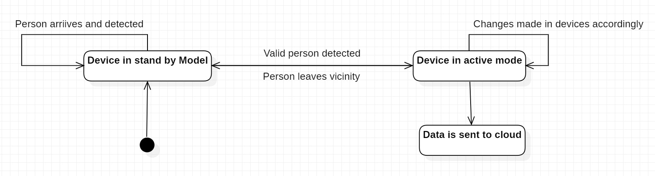

**Figure 22:** State Machine Diagram

**5.4 Data Flow Diagram:**

Data flow diagrams (DFDs) are graphical representations used in systems analysis and design to illustrate the flow of data within a system. They provide a visual understanding of how data is processed and stored, aiding in the analysis and improvement of systems. DFDs consist of four fundamental symbols that represent different elements of the system. Processes are depicted as rectangles and represent operations that transform data. Data flows are shown as arrows and indicate the movement of data between processes or between processes and data stores. Data stores are represented by open-ended rectangles and serve as repositories for data.

External entities, such as people, systems, or devices, are depicted as ovals and represent sources or destinations of data. These diagrams can be used at various levels of detail. A context diagram, which is a high-level DFD, provides an overview of the entire system and its data flow. More detailed DFDs, such as level-1 DFDs, depict major processes and data flows within the system. Further levels, such as level-2 DFDs, can be created to capture additional detail. The benefits of using DFDs are numerous. They allow stakeholders to visualize the flow of data, aiding in the identification of problems within existing systems.

DFDs also facilitate the design of new systems by highlighting opportunities for increased efficiency and effectiveness. Additionally, DFDs serve as a means of communication with stakeholders, enabling clear and concise discussions about the system. Overall, data flow diagrams are a powerful tool in systems analysis and design. They assist in understanding, improving, and communicating the flow of data within systems, leading to enhanced system design and implementation.

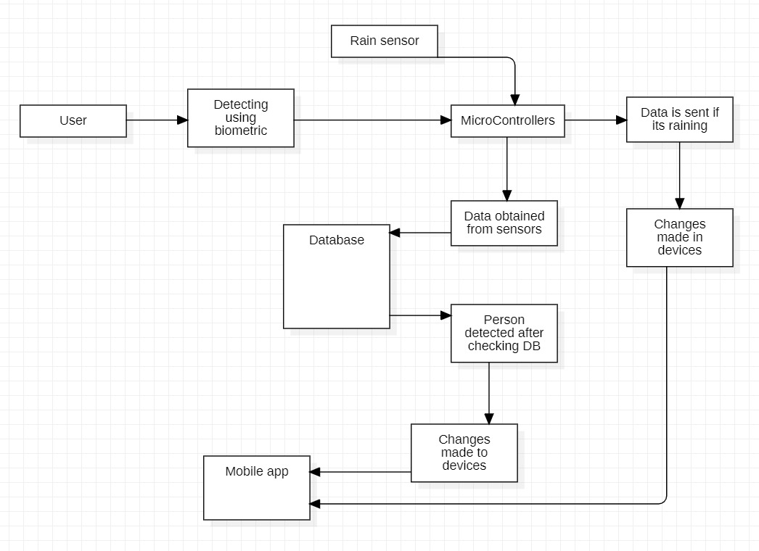

**Figure 23:**  DFD

**5.5 Architecture:**

System architecture in IoT (Internet of Things) refers to the structure and organization of an IoT system, including the arrangement of its components, networks, and communication protocols. It defines how IoT devices, data, and services are interconnected to create a functional and efficient system. In IoT system architecture, there are typically multiple layers or tiers. The perception layer consists of the physical devices or sensors that collect data from the environment. These devices can include temperature sensors, motion detectors, or even wearable devices. The network layer enables communication between the devices and the central system, using protocols such as Wi-Fi, Bluetooth, or cellular networks.

The application layer is responsible for processing and analyzing the collected data, often utilizing cloud platforms or edge computing technologies. The system architecture in IoT aims to address challenges such as scalability, interoperability, and security. It ensures that the system can handle a large number of devices and effectively process the data they generate. Interoperability is achieved by using standardized protocols and interfaces to enable seamless communication between different devices and platforms. Security measures, such as encryption and access control, are implemented to protect sensitive data and ensure the integrity of the system.

An effective system architecture in IoT enables efficient data collection, analysis, and decision-making, leading to improved automation, real-time monitoring, and enhanced operational efficiency. It also provides a foundation for future scalability and adaptability as the IoT ecosystem continues to evolve. By designing a well-defined system architecture, organizations can create robust and reliable IoT solutions that meet their specific requirements and enable them to harness the full potential of IoT technologies for various applications, including smart homes, industrial automation, healthcare, and smart cities.

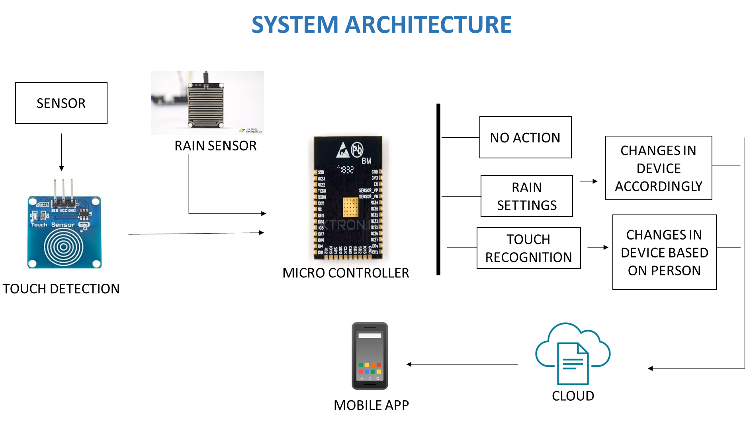

**Figure 24:**  Architecture

**6. IMPLEMENTATION**

**6.1 Sample code:**

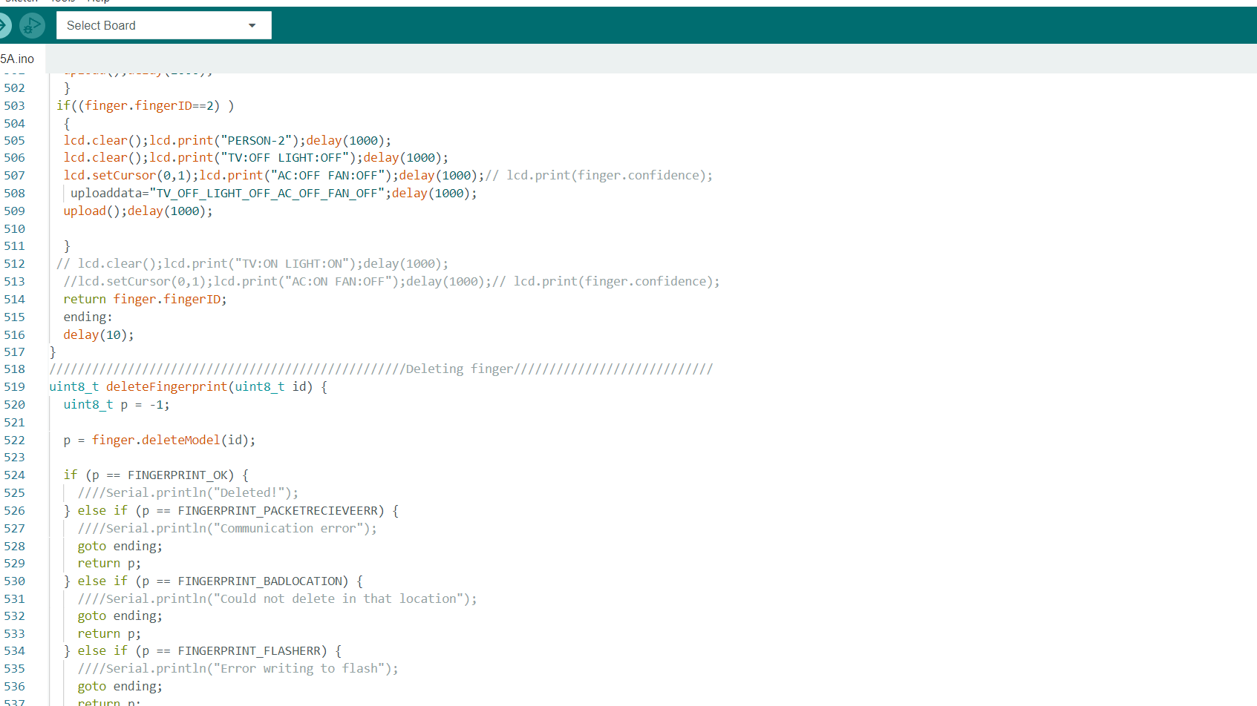

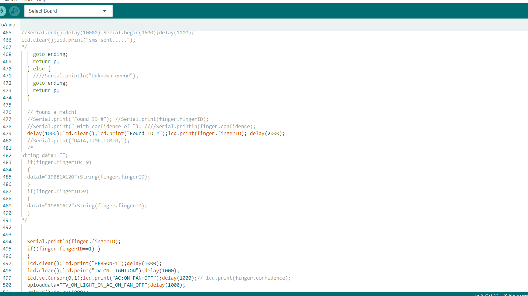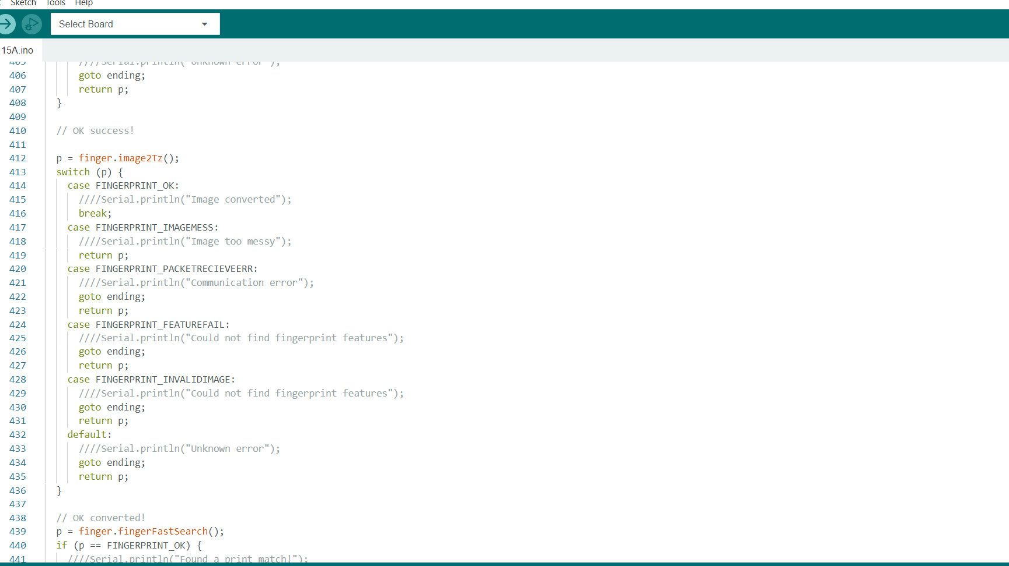

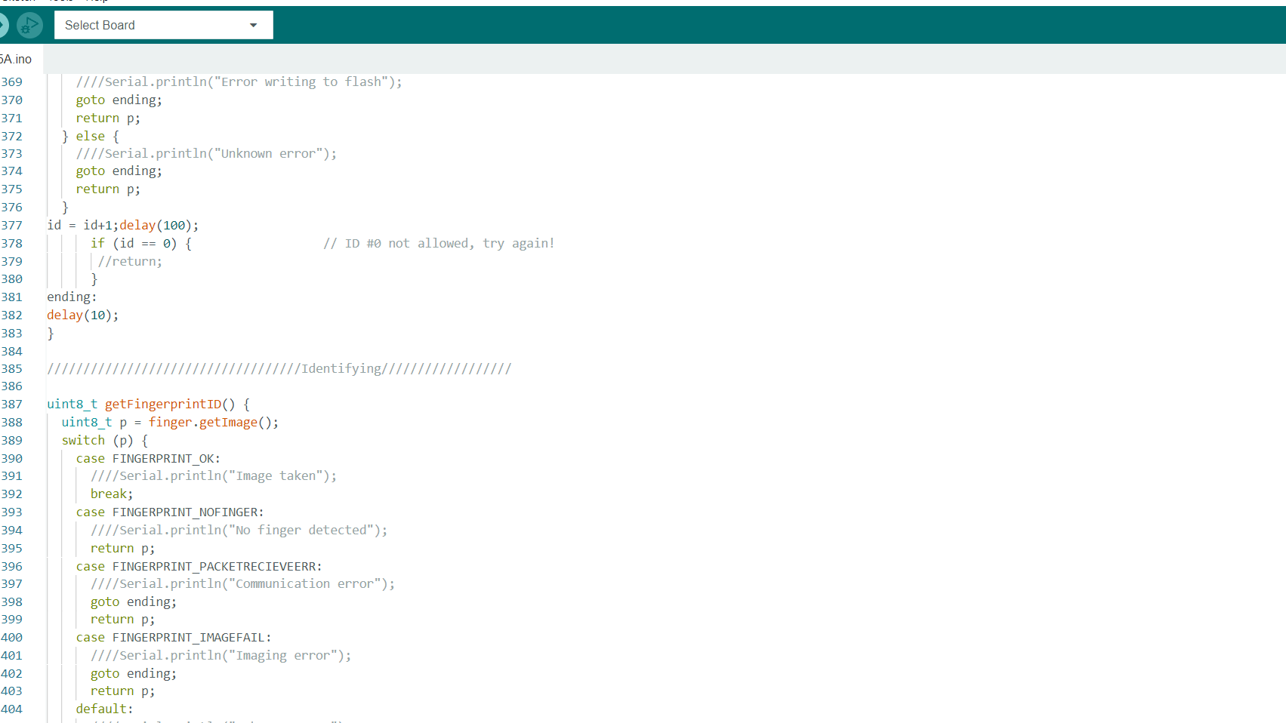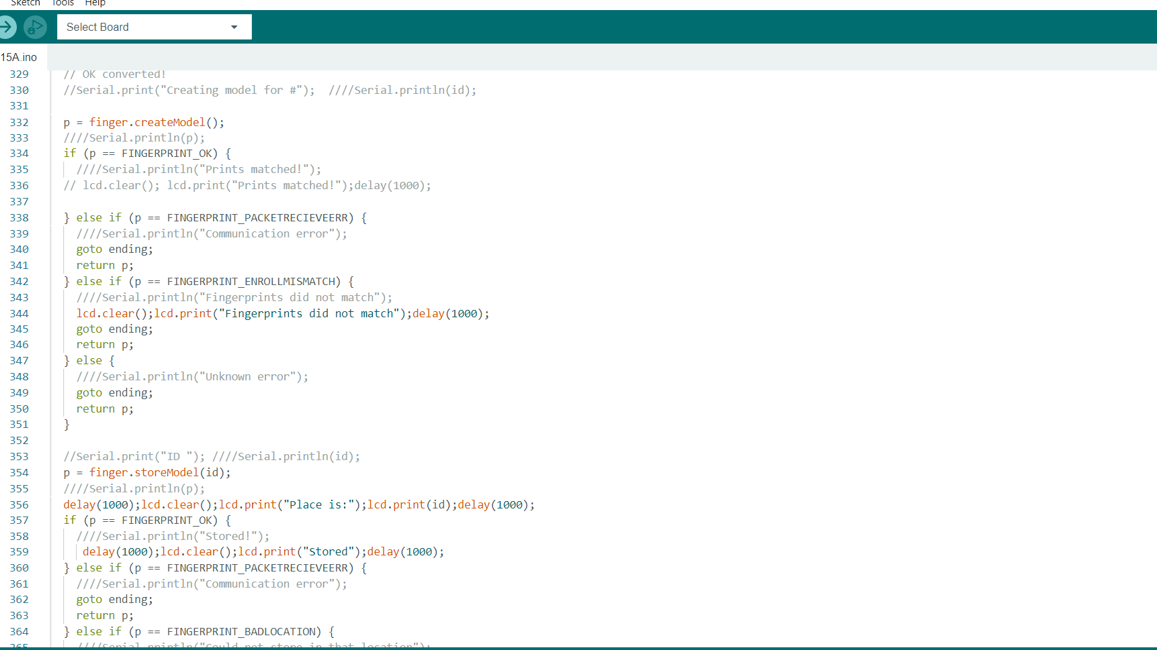

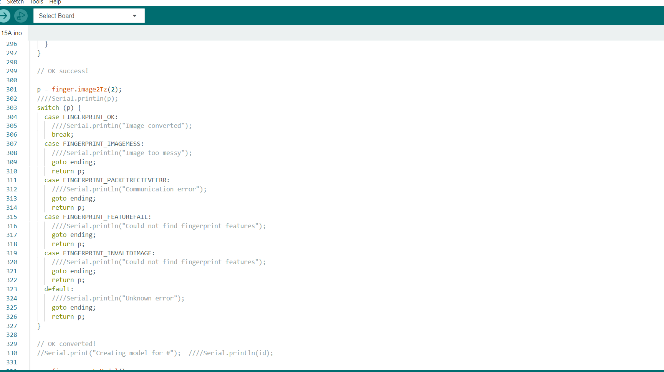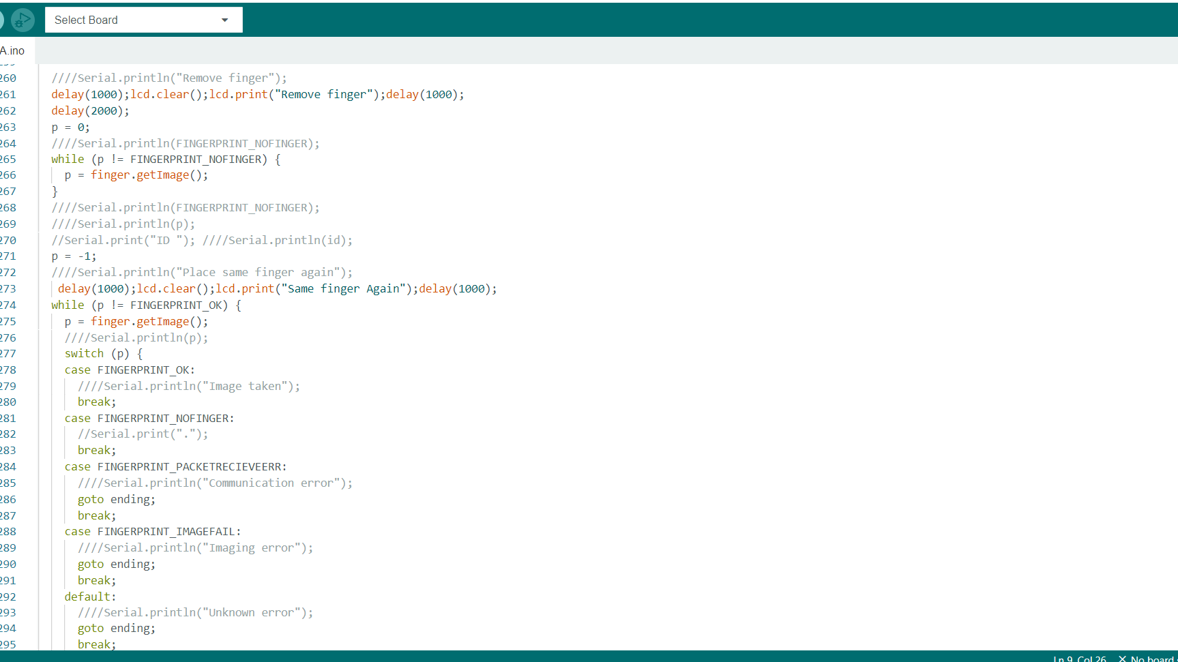

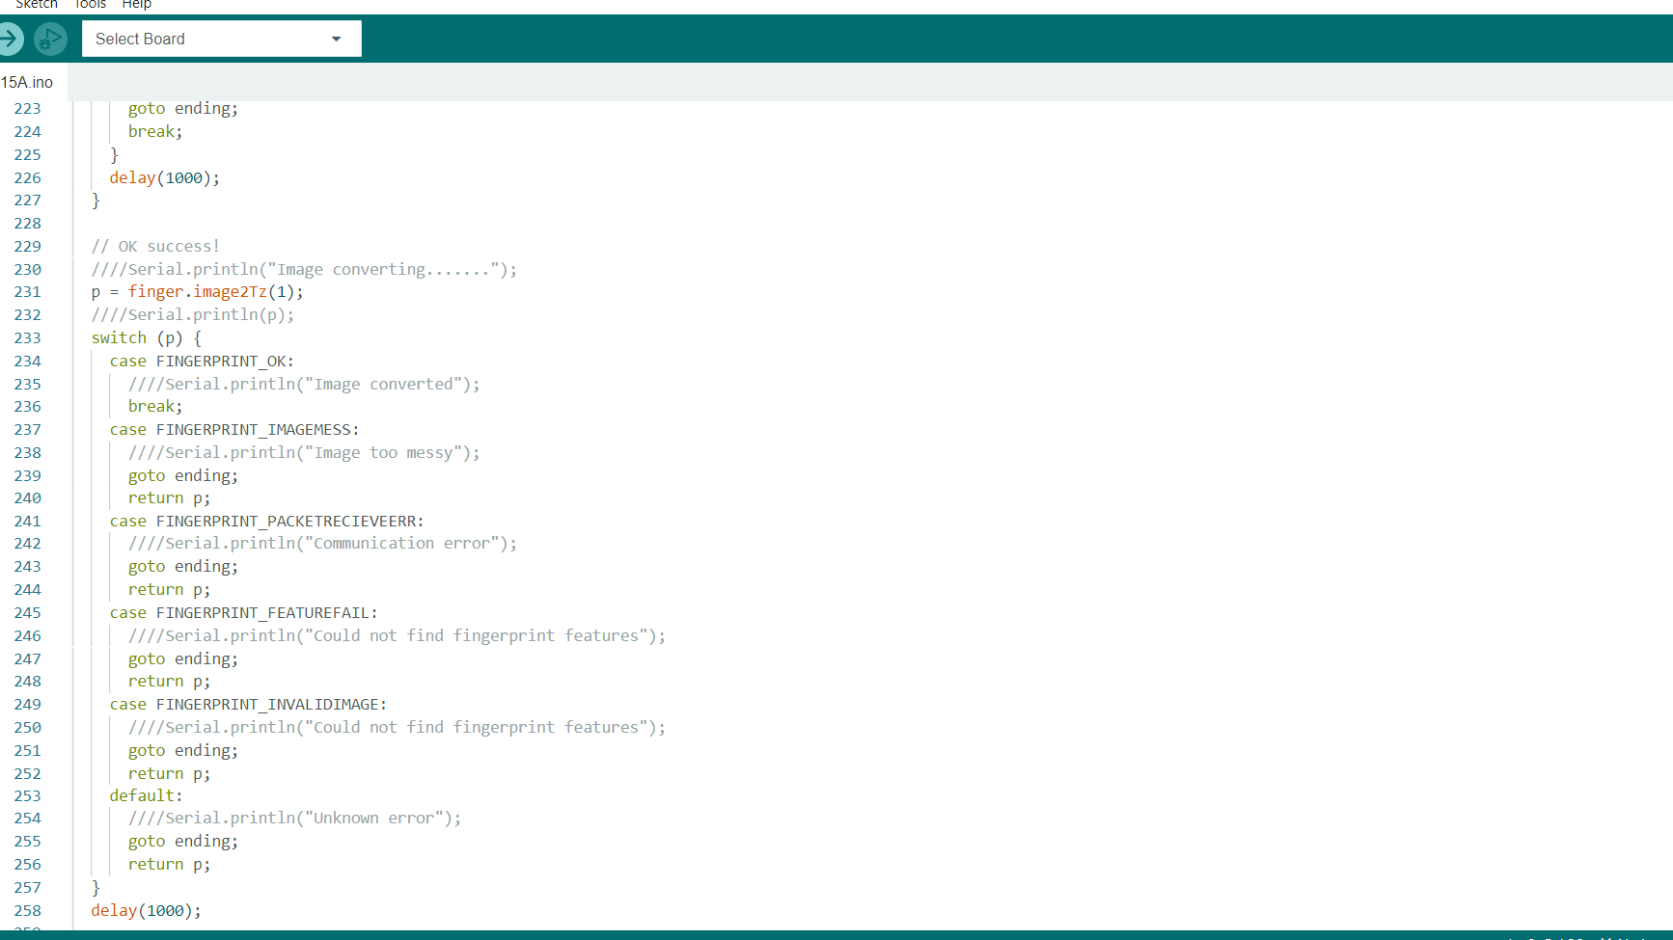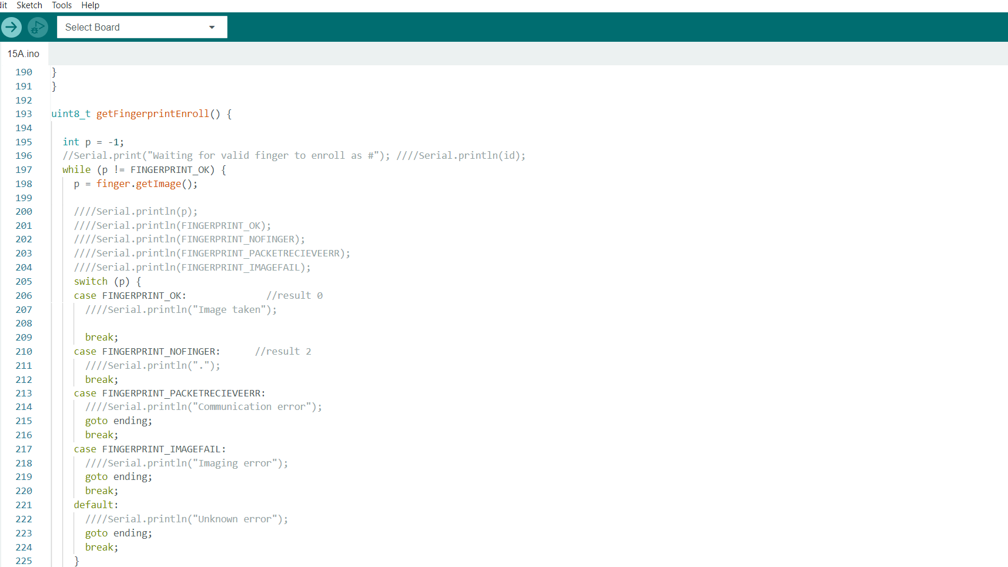

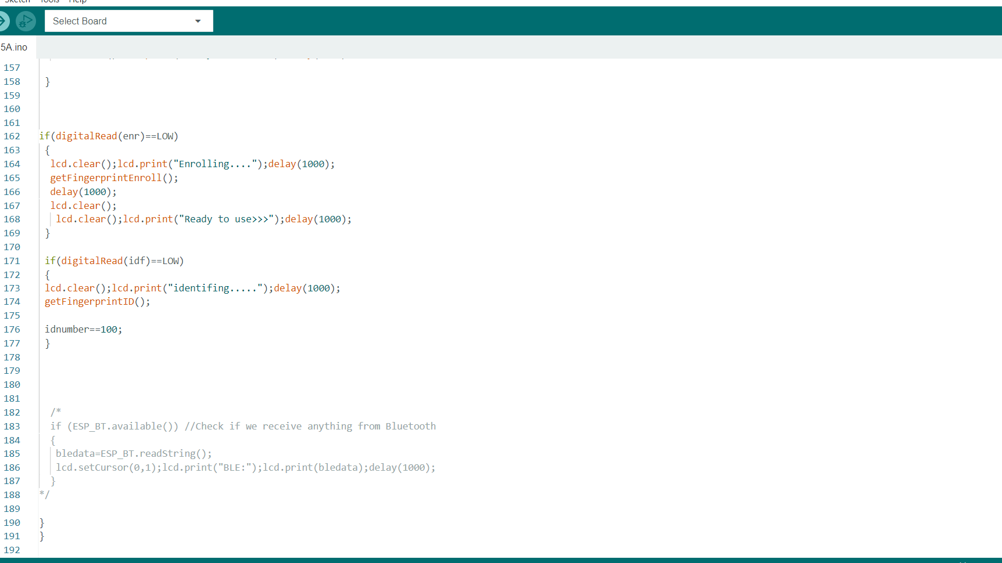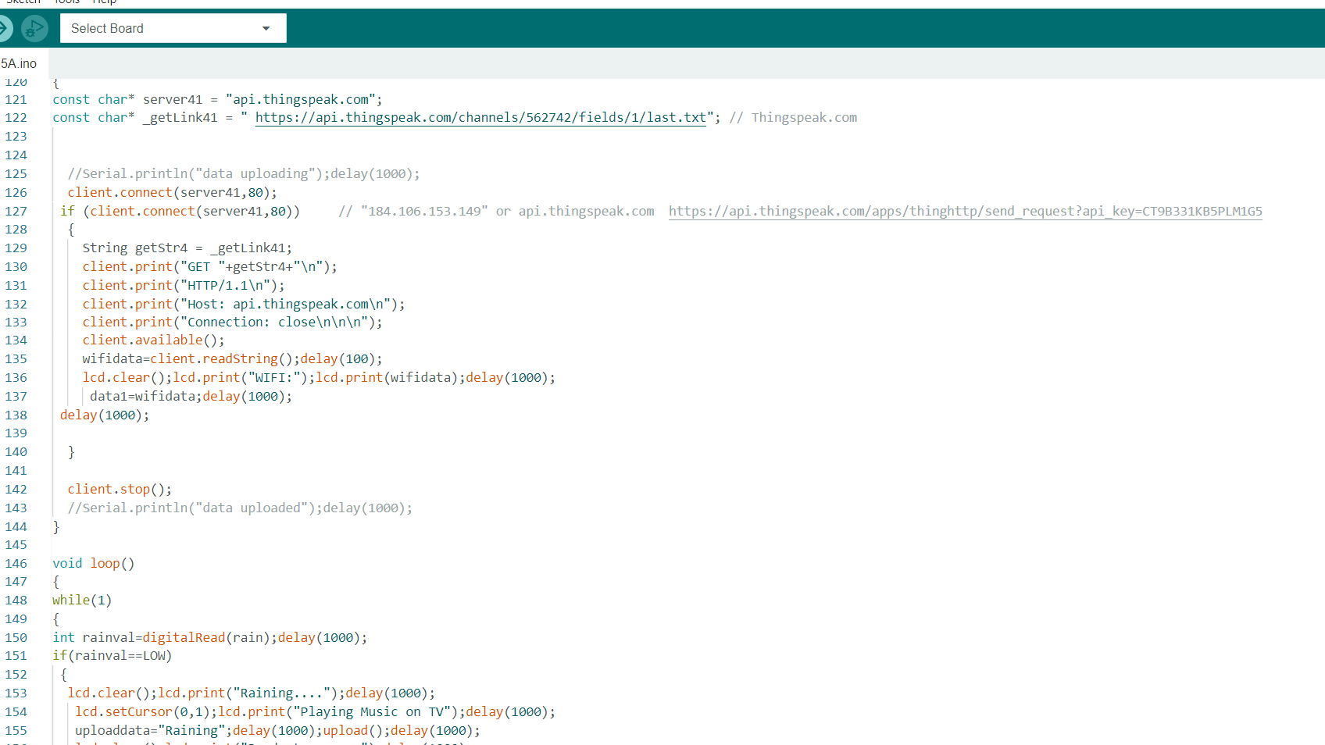

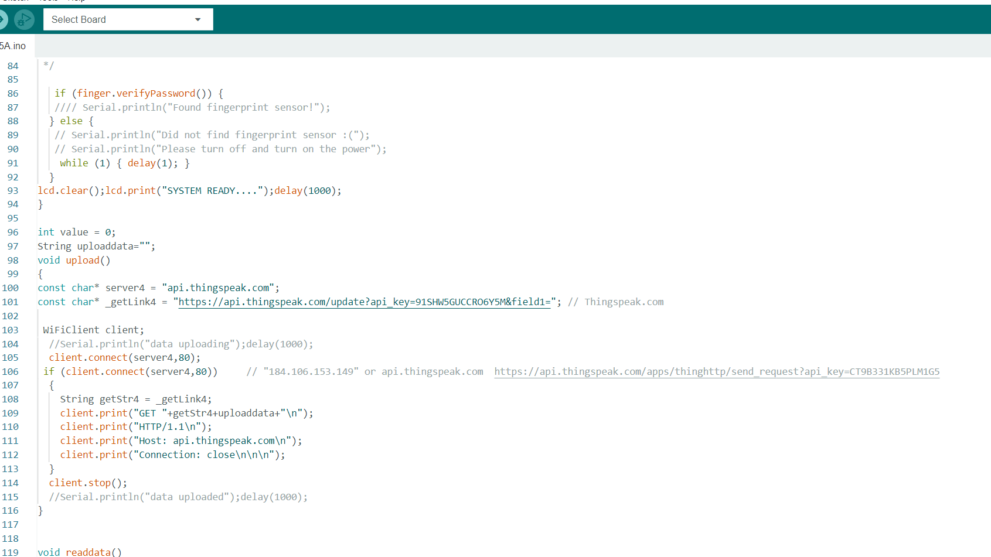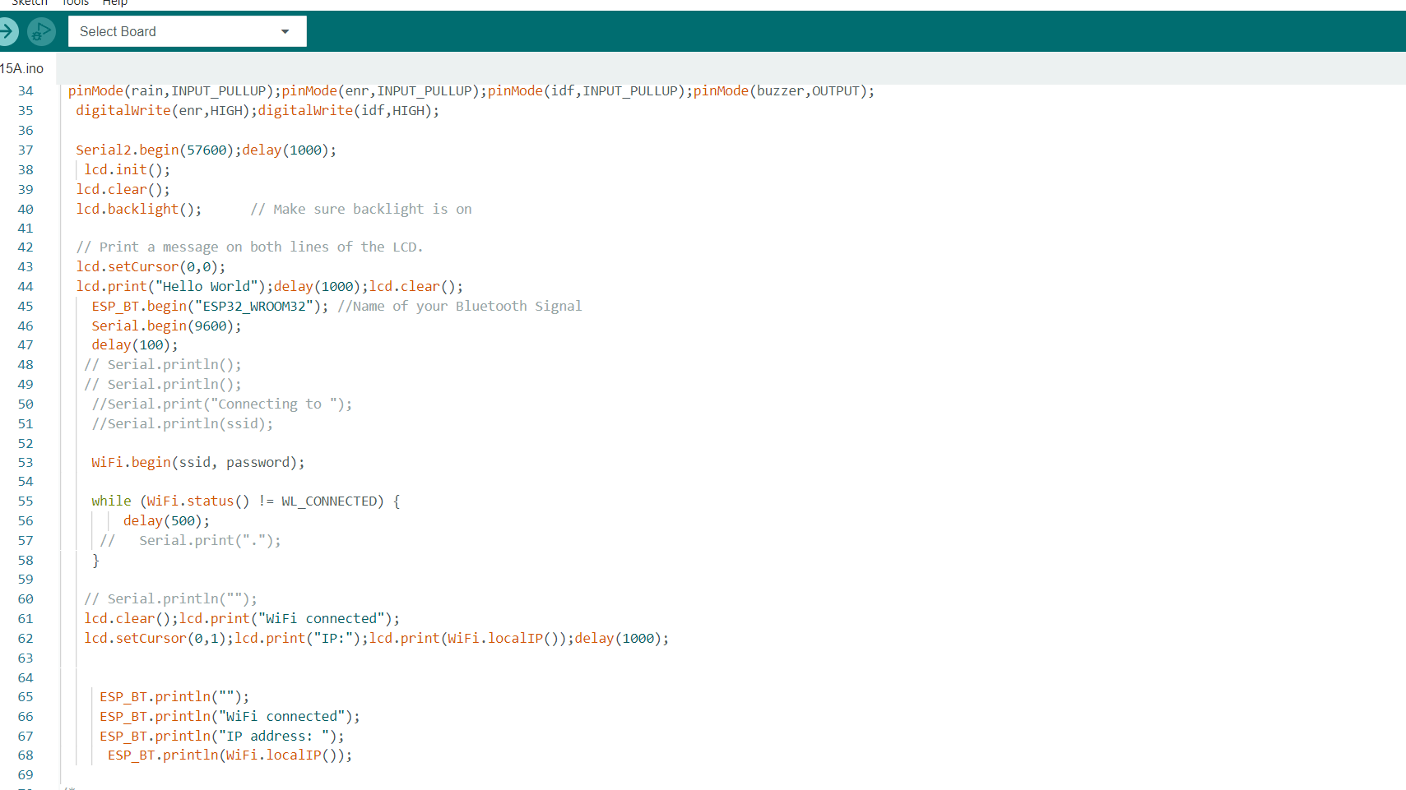

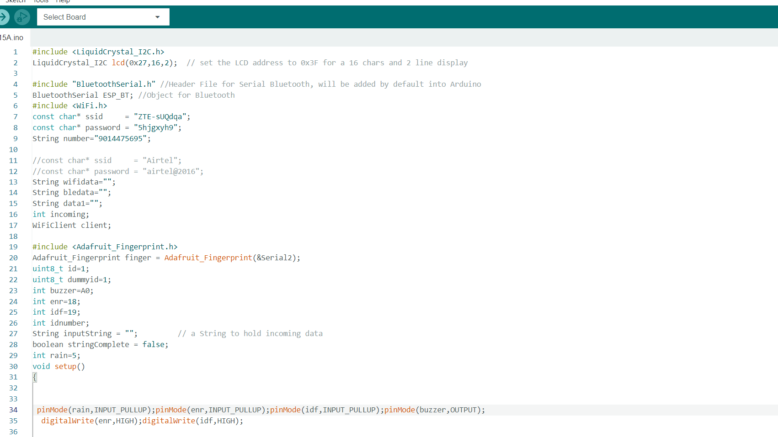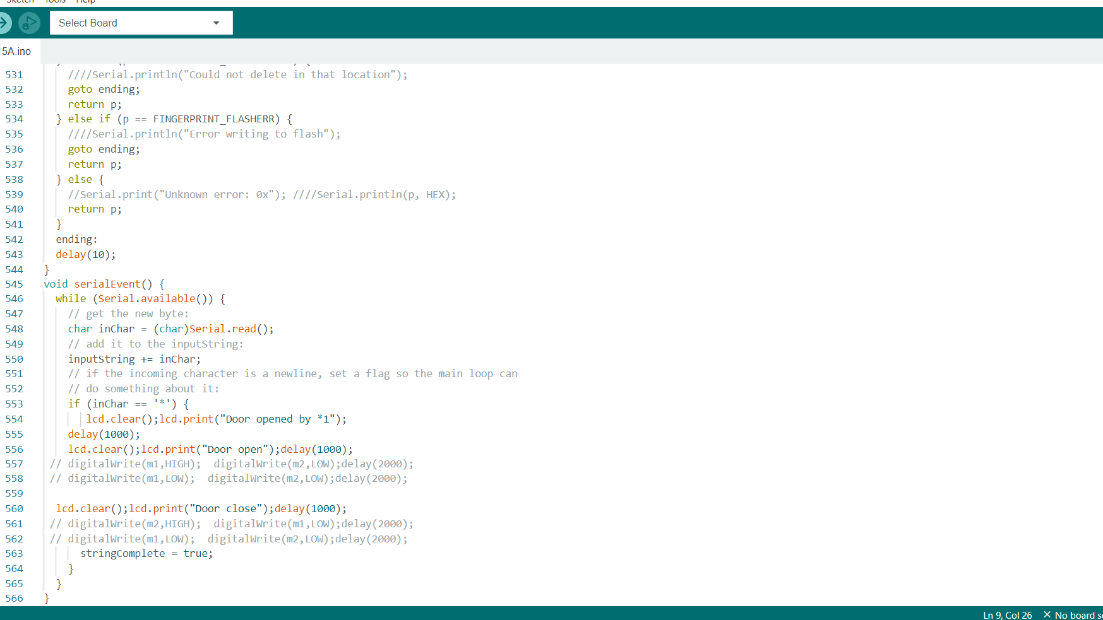

**6.2 Circuit before execution:**

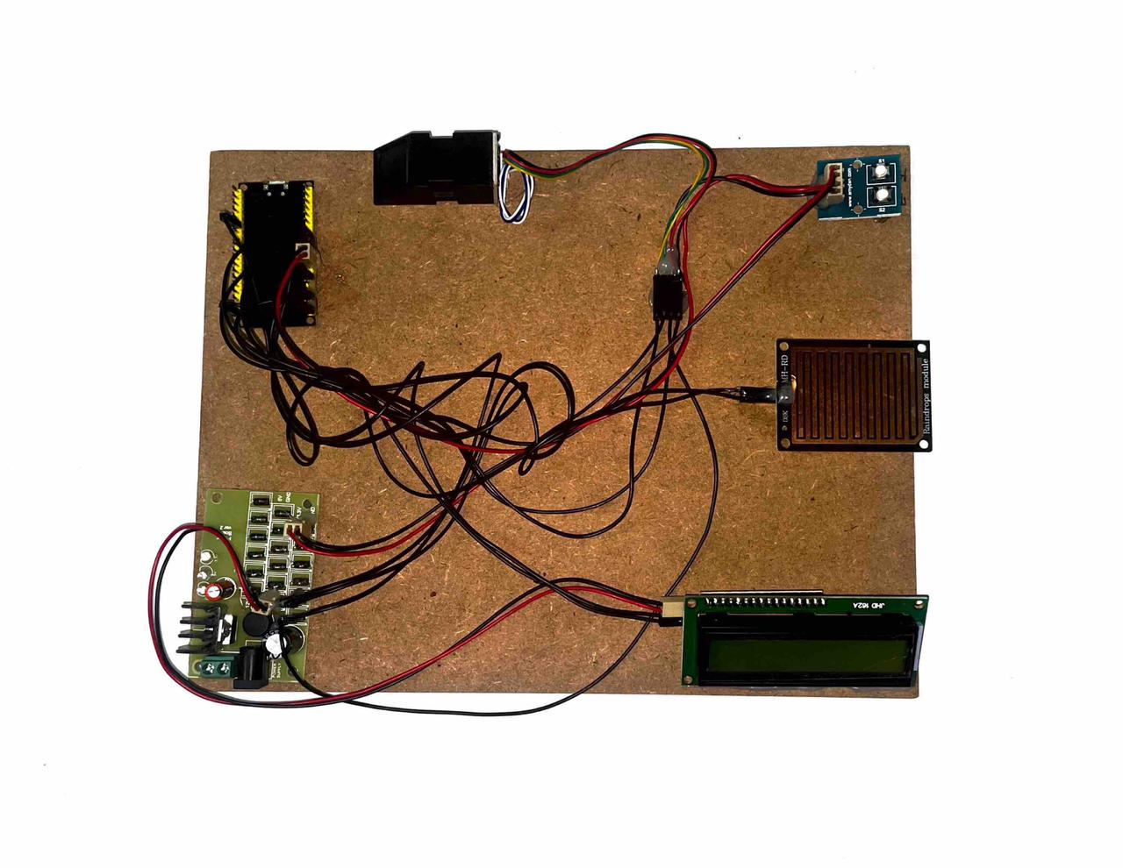

**Figure 25:** Circuit

The circuit module presented in this project illustrates the intricate connections between various components, including the biometric sensor, rain sensor, and LCD display, all interconnected with the microcontroller. By integrating these elements, we create a comprehensive system that enables biometric authentication, monitors rainfall, and displays relevant information on the LCD screen. This intricate network of connections facilitates seamless communication and interaction between the different devices, enhancing the overall functionality and effectiveness of the system. The careful arrangement and configuration of these components demonstrate the attention to detail and precision required in designing a reliable and efficient smart home management solution.

**7. RESULTS**

Upon power connection, the system initiates its startup process, transitioning into the initialization phase. During this crucial stage, all sensors and associated modules, including the biometric sensor, are activated and supplied with power. This simultaneous activation ensures that all components are prepared for operation. To provide a visual indication of the system's status, the LCD display prominently showcases the "System turned on" message, reassuring users that the system is ready for use. This informative display on the LCD screen serves as a convenient and user-friendly interface, enhancing the overall usability and accessibility of the smart home management system. The initialization phase plays a vital role in setting up the system for seamless functionality, ensuring that all components are powered up and operational, ready to deliver the desired performance and fulfill the users' needs.

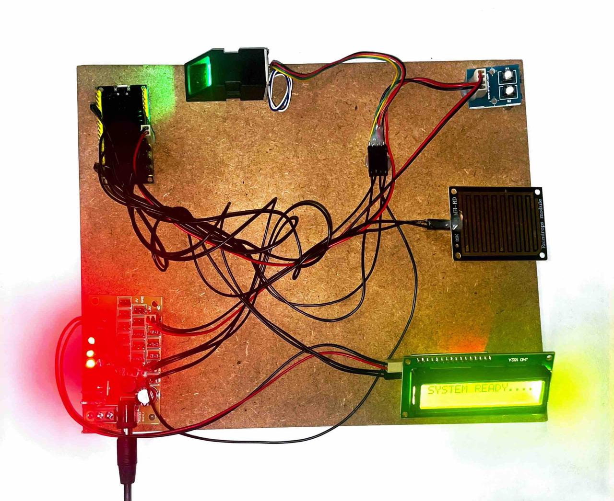

**Figure 26:** Circuit after power supply

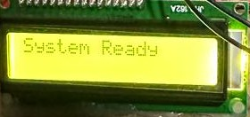

When an individual places their finger onto the biometric sensor, the system initiates a validation process to determine the person's authenticity. The biometric sensor carefully analyzes the unique characteristics of the fingerprint and cross-references it with stored data to verify the person's identity. Upon successful validation, the system generates the required output on the LCD display, showcasing relevant information tailored to the specific specifications of the authorized user. This personalized output can include details such as the information about TV, Fan, light and AC ensuring a personalized and secure user experience. The integration of biometric authentication with the LCD interface adds an extra layer of security and convenience, allowing for quick and accurate identification, thereby enhancing the overall effectiveness and usability of the smart home management system.

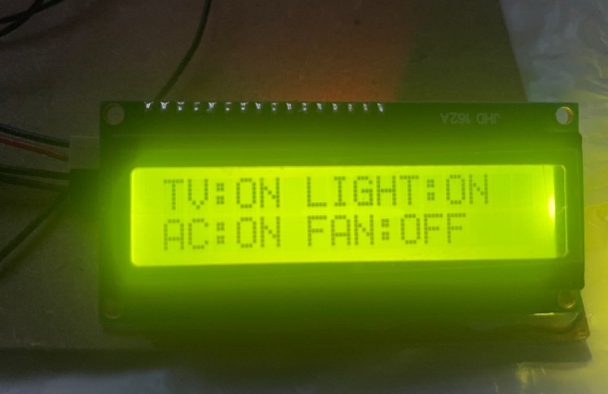

**Figure 27:** LCD Display

In the event of rainfall, the rain sensor promptly detects the presence of raindrops and triggers a response within the system. Once the rain sensor senses rainfall, it initiates a signal that prompts the system to take action. One of the actions triggered by this event is the display of a song on the LCD screen. The system, using predefined algorithms, selects an appropriate song or melody to be showcased on the LCD display, adding a delightful and interactive element to the smart home management experience. This feature not only serves as an entertaining addition but also provides a visual and auditory confirmation of the rainy weather conditions. By combining the rain sensor's real-time detection capabilities with the LCD's display functionality, the system effectively communicates weather information to the user in an engaging and user-friendly manner.

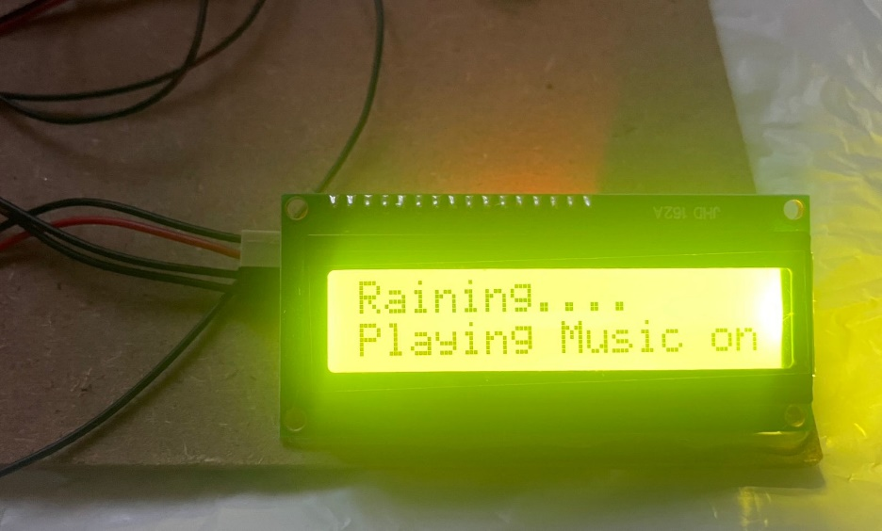

**Figure 28:** Song display

Simultaneously, the collected data can also be accessed and reviewed in the Cloud Database Server provided by ThingSpeak's website. This powerful platform facilitates real-time monitoring of the data, allowing users to observe and analyze the information as it is being recorded. Additionally, the cloud database stores historical data, enabling users to access and review past records and trends. This comprehensive functionality enhances the usability of the smart home management system by providing a centralized location to view and analyze the data. Whether it is checking current readings or examining data trends over time, ThingSpeak's Cloud Database Server offers a valuable resource for users to gain insights and make informed decisions based on the recorded information

**8. SOFTWARE TESTING**

**8.1 Unit Testing:**

During the testing phase, I conducted unit testing for rain sensor used in the project. For the rain sensor, I verified its correct wiring with the ESP8266 microcontroller and tested its accuracy by exposing it to different rain levels. I ensured that the sensor provided accurate readings and responded promptly to changes in environmental conditions. The communication between the sensor and the microcontroller was also verified to ensure reliable data transfer.

I have effectively conducted a thorough examination of the biometric system by successfully establishing a seamless connection with the microcontroller. The results yielded from this meticulous testing process were immensely gratifying, as they demonstrated the system's optimal performance and functionality.

By conducting thorough unit testing for each sensor, I gained confidence in their individual performance and validated their functionality within the project. This testing phase laid a solid foundation for the integration of the sensors with the microcontroller and the overall success of the system.

**8.2 Integration Testing:**

Throughout the integration testing phase of the project, I meticulously examined the integration of sensors with the microcontroller to guarantee the smooth operation of the entire system. Below is an elaborate account of the integration testing procedure:

1. Wiring and Connections:

With utmost care and attention to detail, I established secure connections between each sensor and their designated pins on the ESP32 microcontroller. This involved meticulously following the provided wiring diagrams and guidelines to ensure accurate alignment and reliable communication between the sensors and the microcontroller. The focus was placed on securing the connections to maintain a stable and uninterrupted flow of data throughout the integration testing phase.

2. Code Integration:

In the process of code integration, I successfully incorporated the essential libraries and dependencies into the project code, enabling seamless communication with each sensor. To ensure efficient data collection and processing, I diligently defined the necessary variables and objects for each sensor within the code. Moreover, I meticulously configured the pin modes and settings within the code, establishing robust communication channels between the sensors and the microcontroller. By carefully implementing these steps, the code was optimized to facilitate effective interaction with the sensors and facilitate their functionalities.

3. Testing and Debugging:

I conducted comprehensive and meticulous testing to guarantee the accurate and reliable functioning of the integrated system. I carried out thorough verification procedures to validate the precision and consistency of the sensor data. By testing diverse scenarios and inputs, I assessed the system's response and decision-making capabilities, ensuring their correctness. In instances where issues or inconsistencies arose, I diligently reviewed the code, examined the wiring connections, and analyzed the sensor outputs. This rigorous debugging process enabled me to identify and resolve any problems, ensuring the smooth operation of the integrated system.

**9. CONCLUSION AND FUTURE ENHANCEMENTS**

**9.1 Conclusion:**

In this study, we have introduced a sensor-based smart home management system that addresses both security concerns and personal preferences of individuals. The system offers flexibility, adapting to different user specifications. By seamlessly integrating and automating various devices, we have successfully enhanced convenience, security, and energy efficiency within the home environment. With the ability to remotely control and monitor multiple systems, our solution simplifies daily tasks and provides homeowners with peace of mind. It highlights the immense potential of IoT technology and offers a glimpse into a future where smart homes are commonplace. As IoT continues to evolve, it has the potential to further enhance our quality of life and revolutionize our interaction with living spaces.

**9.2 Future enhancements:**

Our proposed model has the potential for further development by incorporating additional security features such as thief detection and an alarm system. Moreover, enhancing the system to include gas leak, smoke, and fire detection would significantly bolster its capabilities, making it even more powerful than its current state. This expanded functionality would not only increase performance but also benefit a wider range of users in numerous ways. By continuously improving and refining the model, we can ensure its effectiveness in providing a safe and secure living environment while addressing the evolving needs of individuals. This ongoing development will contribute to the wider adoption and positive impact of smart home management systems in the future.

**10.BIBLIOGRAPHY**

|  |  |
| --- | --- |
| [1] | Dr .R.Parimaladevi, AN OVERVIEW ON INTERNET OF THINGS, 2020 JETIR April 2020, Volume 7, Issue 4 |
| [2] | Mrs.Jyotsna P. Gabhane, Ms.Shradha Thakare, Ms.Monika Craig Smart Homes System Using Internet-of-Things: Issues, Solutions and Recent Research Directions, Volume: 04 Issue: 05 | May -2017 |
| [3] | Ahmad Bilal Zia, Ms. Kshamta Chauhan, A Research Paper on Internet of Things based upon Smart Homes with Security Risk Assessment using OCTAVE Allegro, Vol. 9 Issue 06, June-2020. |
| [4] | Mohit Kumar Saini, Rakesh Kumar Saini, Internet of Things (IoT) Applications and Security Challenges: A Review, Volume 7, Issue 12, ISSN: 2278-0181 Published by, www.ijert.org NCRIETS –2019 |
| [5] | Dr. Anitha Chepuru, Ginka Sai Lakshmi Priyanka, Seethala Pradeep Visharika, Veda Rishitha J, Student, Vejalla Rishitha, Student “IoT AND TOUCH-BASED HOME AUTOMATION“ International Journal for Research in Engineering Application & Management (IJREAM) ISSN : 2454-9150 Vol-06, Issue-01, Apr 2020. |
| [6] | Ms. K. S. Gulghane, Dr.Mrs. S. S. Sherekar, Dr.V.M.Thakare “IOT BASED SMART HOME AUTOMATION SYSTEM ” Journal of Emerging Technologies and Innovative Research ISSN-2349-5162 Volume 6, Issue 4, April 2019. |
| [7] | Hithaishi R , Anusha M , Aishwarya S , Abhilasha T S “Optimized Hand Gesture Based Home Automation For Feebles” International Journal of Research in Engineering and Science (IJRES) ISSN (Online): 2320-9364, ISSN (Print): 2320-9356 Volume 10 Issue 5 2022 . |
| [8] | Ankush Muley , Piyush Changan, Balaji Londhe and Prof. S. B. Pokharkar “Human Detection System” International Journal of Advanced Research in Science, Communication and Technology (IJARSCT) Volume 6, Issue 1, June 2021 . |
| [9] | Balwinder Kaur Dhaliwal, Arvinder Kaur, Muskan Bhutani, Naman Thakur, Akash Singh, Bhavnath Jha “Smart Home Automation System Using IOT” International Journal of Creative Research Thoughts (IJCRT) | ISSN: 2320-2882 Volume 9, Issue 4 April 2021 |